Compassion First:
Designing our national approach from the lived experience of suicidal behaviour
A Report developed by the National Suicide Prevention Taskforce as part of the Interim Advice to the Prime Minister
August 2020

Contents
Foreword
Acknowledgements 1
Snapshot 2
The research identified some clear opportunities for change 3
About the research 4
Summary of commissioned research 5
Contributing factors in a person’s journey 6
Key themes identified through research 6
Mapping journeys 11
Experiences with services 15
A crisis-driven system with multiple ‘drop-off’ points 15
Lack of communication, integration of services and follow-up 17
Gaps in the system 18
The need for a compassionate workforce 20
Experiences with other services and agencies 21
Helpful responses that shift trajectories 22
Shifting the lived experience narrative 24
Public voices: shifting from anecdote to expert 24
Diversity in lived experience 25
Sharing as healing 25
Opportunities for change 27
Acknowledgements and references

To cite this document:
National Suicide Prevention Taskforce. Compassion First: Designing our national approach from the lived experience of suicidal behaviour. Canberra; August 2020.

Foreword
Australia’s approach to suicide prevention must be informed by the experiences and wisdom of people with lived experience of suicide and recovery.

In Australia, we often cite the number of people who die by suicide each year to highlight the scale and impact of the issue, but this is only part of the overall picture. Behind each of those numbers is a person, a journey and a network of other people.
We also need to look beyond suicide deaths. Suicide prevention efforts must learn from those who experience suicidal distress and suicidal thoughts, and from the resilience displayed by people who are recovering from suicide attempts. All too frequently these experiences are poorly understood.
It is important to make urgent improvements to our access to and use of suicide-related data, to prioritise research and to hear from academics, clinicians and service providers. However, this is not enough. We also need to elevate the voice of people with lived experience of suicidal behaviour. Not as an anecdote or story to strengthen advocacy, but to shape and guide our reform efforts in Australia.
Our Initial Findings presented to the Prime Minister in November 2019 identified the need for a coordinated response to suicide prevention and an urgent need to better understand the journeys and experiences of those who have lived experience of suicidal distress and suicide attempt to guide the shift to a whole of government approach. This report, Compassion First draws on 2020 research of those with first-hand experience of suicidal behaviours. It is essential reading for anyone interested in how we can improve not only our understanding of suicide but how we can more effectively prevent suicidal behavior, attempts and deaths.
The research highlights the importance of a national approach to suicide prevention that spans all ages, acknowledging that many challenges commence early in life and can be exacerbated by stressors and co-occurring adverse life events in later years. If the health, social, cultural and equity issues contributing to suicide are understood and touchpoints along people’s journeys identified and resourced to provide support, there are numerous opportunities to assist people before they reach crisis point.
We need to do all we can to prevent suicidal behaviour by intervening much earlier to interrupt the common pathways that lead to suicidal behaviours. We must also urgently transform our service system, a system that people describe as disconnected, crisis-driven and dehumanising, where the traumatic and systemic factors that often contribute to suicide are rarely acknowledge.
We have no option but to position lived experience knowledge at the forefront of research, policy and practice. Without it our reforms and service improvements will fall short of what people need and what people deserve.

Christine Morgan
National Suicide Prevention Adviser

Acknowledgements

.
“We know the desperate powerlessness that is inherent in feeling suicidal…so much energy must go into healing one’s self and building a life worth living that challenging the stigma and discrimination that exists even in the field of suicide prevention is beyond any individual-let alone challenging the complex, entrenched systems that contribute to suicide. Reassuringly, the collective voice of those who have lived experience of suicide, standing on the shoulders of the giants who have fought for social justice, has finally gained traction and momentum, kindling the spark of hope for change.”
Statement from Lived Experience contributor at the Black Dog Institute
The National Suicide Prevention Taskforce and all researchers who contributed to studies used for this report would like to acknowledge the people with lived experience of suicidal behavior who contributed via the online survey, or in one of the consultations or yarning circles. We acknowledge their contribution in such an open and honest way, knowing that it will directly contribute to our future work in suicide prevention. Without this input we would not have their expert insights to guide improved solutions.
The National Suicide Prevention Taskforce acknowledges the researchers who contributed to the report (see reference section for a full list) and members of the Expert Advisory Group with lived experience of suicidal behavior who contributed to the planning and review of this report - Ingrid Ozols AM, Stefani Caminiti, Graeme Holdsworth, Parker Forbes, Leilani Darwin and Lucinda Brogden AM.
‘Lived experience’ is a broad term used to describe people who live with suicidal thoughts, who have survived a suicide attempt, who have been bereaved by suicide and those who care and support someone who was or is suicidal. All of these experiences are important in informing our suicide prevention work. This report, however, primarily focusses on the experiences of those who have lived through a suicide attempt.
Aboriginal and Torres Strait Islander Lived Experience is a relatively new area of research, but evidence suggests that Indigenous peoples’ experience of suicide is inherently different to other experiences of suicide. The effects of colonisation and its associated trauma weigh into this lived experience.

Snapshot

There is an imperative to harness the knowledge of those who have lived experience of suicidal behaviour to inform our national approach.

- This report summarises key insights from people with lived experience of suicidal behaviours, drawing on commissioned research to learn from thousands of people with first-hand experience.
- While there are some common experiences that may precede a suicide attempt, there was no simple or singular pattern of experiences – suicidal behaviour is very personal and deeply distressing.
- For many, suicidal thoughts and behaviours could be traced back to childhood and adolescent experiences of abuse, violence, trauma, family conflict or bereavement. People also reported experiences with mental illness, alcohol and other drug problems discrimination and cultural taboos as well as the role of co-occurring and complex life stressors closer in time to a suicide attempt.
- What people need when in distress is a connected and compassionate response, but instead they described their reality as feeling “unheard, judged and problematised” by disconnected crisis-driven services.
- The research described a common and distressing scenario where, precisely when people are highly distressed and in need of a compassionate response, our health system and other related systems provide disjointed care that is lacking in empathy or not available at all.
- The unintended consequence of this for most people is that responses can do more harm than good, perpetuating a vicious cycle where individuals in distress can only access support when in crisis at which point they are judged for not seeking help earlier.
- People also spoke of needing to try and navigate support options on their own which could be more isolating and distressing, especially when the referral systems were siloed – attempting to ‘treat’ just one presenting issue at a time rather than supporting a person as a whole.
- There was a sense through the research that a seismic rather than small shift in the approach is required. Multiple drop off points, a lack of integration and communication between services, cultural barriers and a lack of supports for caregivers were all described.
- A range of other potential supports and services were identified, including housing and homelessness service, legal centres and the family law court, family and community services, including services that support people through domestic and family violence, as well as a range of financial and other community services.
- The research conducted for this report points to the need for a serious shift in the public representation and narrative around suicide – including who it affects, how it is best responded to and transparency about the shortcomings of the current system.
- In media and other public messaging, lived experience was often seen as anecdote to reinforce an ‘expert’ or clinical view or opinion, with limited coverage of people who have lived through a suicide attempt.

The research identified some clear opportunities for change
- Lived experience knowledge and expertise to be prioritised and integrated into the planning and delivery of whole of government suicide prevention action.
- Population-level interventions that address key social and economic stressors implemented.
- Intervene early in life to mitigate the impacts of abuse and adversity in childhood.
- Effective interventions and available support options for young people to mitigate the impacts of co-occurring psychological and relational stressors.
- A more comprehensive approach that addresses the multiple impacts of alcohol and other drug use on suicidal behaviour.
- Increased capacity to provide outreach and support at the point of distress to ensure people get the right supports in a timely way – especially at critical points of disconnection and transition
- Increased supports for those exposed to the suicidal behaviour of others, in particular for Aboriginal and Torres Strait Islander communities and for young people in schools.
- A range of compassionate services and supports need to be available for people who do seek help in suicidal distress. This includes:
    - Developing and supporting the broad range of workforces involved in suicide prevention to respond with compassion to underlying distress.
    - New ‘entry’ points and service models that align with a compassionate response - including ‘safe spaces’ and peer-led services.
    - Improved health service responses – especially through emergency departments.
    - Service models that support psychosocial needs, care-coordination and ongoing follow up – including broad access to aftercare.
    - Safe and culturally appropriate services for all people
- Better supports for family and caregivers, many of whom experience suicidal thinking themselves.
- Interagency and cross-portfolio approaches that connect with and support people across a range of settings.

About the research

Positioning knowledge from lived experience at the forefront of research, policy and practice has the potential to richly communicate the complexities of suicidal behaviour and highlight key considerations for preventing suicide and better supporting people.

To expand on existing research and practice knowledge, the National Suicide Prevention Taskforce partnered with the Suicide Prevention Research Fund (managed by Suicide Prevention Australia) to commission research that focussed on learning from people in Australia who have first-hand experience of suicidal distress and suicide attempts.
Seven separate studies were commissioned to explore: (1) what people with lived experience reported as the most significant factors contributing to their suicide attempt or distress; and (2) their experiences with a range of health and non-health services in the lead up to, during and following their suicide attempt or suicidal distress.
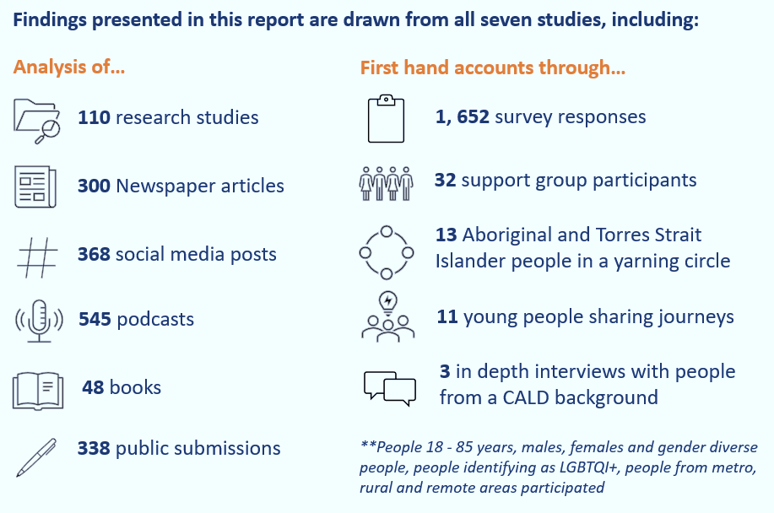
A limitation in the current research was the inability to identify diversity of the participants in terms of cultural background, LGBTIQ+ status, where people lived or other important demographic and background information. Additional research is in progress, or will be conducted in 2020, to address some of these gaps.

Summary of commissioned research
Seven separate studies were commissioned, including a review of existing research, a large online survey, analysis of public commentary about lived experience of suicide and targeted consultations with identified target groups, as summarised below.
- Rapid evidence review. Researchers and Lived Experience Advisers at the Black Dog Institute conducted a rapid review of the available evidence, with a total of 110 papers or reports included in the review, 26 of which were from Australia. Most studies were qualitative and examined individuals with direct experience of suicidal thoughts and behaviours. They focused on a variety of populations such as men, young people, older people, military veterans, people identifying as Lesbian, Gay, Bisexual, Transgender, Queer or Intersex (LGBTIQ+), and people from culturally and linguistically diverse backgrounds (CALD).
The University of New England conducted and reported on three studies:
- Public Voices: Exploring how lived and living experience of suicide is portrayed in the public domain, including news media, books, social media, podcasts and submissions to public enquiries.
- Private Voices: Examining responses of 1,652 people who completed an open-ended, open format online survey. In this survey, the researchers simply asked people to tell them about what suicide and lived experience of suicide means to them.
- Empowered Voices: Re-examining data from 32 people who had attempted suicide and completed a psycho-educational support group offered by Lifeline centres in New South Wales.
Three organisations were commissioned to conduct targeted consultations:
- Consultation with Young people. Orygen conducted consultations with 11 young people regarding their lived experiences of suicidality and associated help-seeking. Young people were recruited from across Australia and ranged from 17-25 years of age. Seven identified as female, three as male, and one as non-binary. Five of the young people identified as LGBTIQ+, including two transgender young people.
- Consultation with Aboriginal and Torres Strait Islander people. The Aboriginal and Torres Strait Islander Lived Experience Centre in partnership with the Seedling Group and Black Dog Institute conducted virtual yarning circles with 12 Aboriginal and 1 Torres Strait Islander person with a lived experience of suicide to explore factors contributing to suicidal behaviour and experiences with services. The yarning circles included four males, eight females and one gender fluid person. Participants lived in five different states and territories, including metropolitan, rural and remote areas.
- Consultation with People from a culturally and linguistically diverse background. Three initial in-depth interviews were conducted by Cultural and Indigenous Research Centre Australia (CIRCA) with people from a Chinese, South African and Greek background, with ages ranging between 27 and 70 years.

Contributing factors in a person’s journey

“Being suicidal is exhausting and all-consuming. Most of the time, those who are suicidal are also trying to keep their and their family’s day-to-day life afloat. Expectations on us to reach out, follow up, navigate siloed services and systems, chase referrals, do extra or self-advocate are completely unrealistic.”
Statement from Lived Experience contributors at the Black Dog Institute
In the thousands of stories shared through the research, not one participant described a simple lead up to a suicide attempt. While suicidal behaviour is often viewed as a passing event, many people highlighted that thoughts of suicide do not resolve quickly or easily for everyone. For many, suicidal thoughts and behaviours could be traced back to childhood and adolescent experiences of abuse, violence, trauma, family conflict or bereavement. People also reported experiences with mental illness, alcohol and other drug problems discrimination and cultural taboos as well as the role of co-occurring and complex life stressors closer in time to a suicide attempt. The table on the next page summarises some of the contributing factors that were mentioned across life stages.

Key themes identified through research
Adverse experiences and trauma in childhood
Early adverse childhood experiences were very common across all research studies. Childhood sexual, physical and psychological abuse was often named as the first experience in a long journey of poor mental health, unstable or violent relationships, social isolation and suicide attempts. For many people, this abuse occurred in the home, but others reported abuses from institutions such as churches and schools as well as services responsible for the removal of children from their homes. Some people reported suicide attempts close in time following the abuse, while others reported that a suicide attempt occurred decades later.
In many cases, family violence was part of the person’s childhood experience, as well as parental experiences with mental illness, alcohol and other drugs and suicidality, sometimes requiring children to take on caring roles for other family members. Participants spoke of how they and their families did not receive adequate support to mitigate some of the impacts of these early life experiences.
Some people spoke of a ‘pipeline’ between childhood trauma, early experiences with the juvenile justice system and re-entry into the justice system as an adult, with comorbid mental illness and drug and alcohol problems presenting for many people. Intergenerational experiences of parental mental illness, substance dependence and incarceration can have a cyclical, compounding impact that lasts throughout life.

“I live a life where suicide will always be a risk factor – for myself and for my loved ones. Neglect, incest, sexual abuse and sadistic parents gave all my family a life sentence of severe trauma and life-long mental health challenges. Suicide has never been far from any of our minds. I have attempted suicide and I’ve sat beside siblings and called ambulances as I watched them after theirs attempts to suicide. I lost two friends to suicide and I still sit overnight with others in hope that my company means they live to see the next morning.”
Personal story, Private Voices study, UNE
For people from a CALD background, childhood trauma was discussed in the context of migration experiences, which often occurring at a young age. As children and adolescents they could also experience conflict between expectations of parents to maintain cultural factors and behaviours and a desire to take on values and behaviours of their new country.

“The mental health journey of migrant children is very undervalued and there are two sets considerations, the first is the issues and traumas they bring when they come to Australia, the second is the issues associated with trying to fit in here.”
Culturally and linguistically diverse interview participant
Mental illness and alcohol and other drug problems
Mental illness and alcohol and other drug problems were present in many people’s stories, often with onset in adolescence or early adulthood. While young people and a number of adults talked about ongoing challenges with complex mental illness close in time to their suicide attempt, more often than not it was described as sitting in the background in the context of trauma, disadvantage and inequity. Lack of access to mental health or counselling services or poor experiences of care were also described. Alcohol and other drug issues emerged in adolescence for many people, with some reporting ineffective treatment or a lack of treatment at the time. Many people, especially men, described a change or increase is alcohol or substance use co-occurring with life stressors close in time to a suicide attempt, especially co-occurring with relationship breakdown.

“I have had multiple family members attempt suicide and I have as well. I am a recovering addict and have been sober for 20 years. My attempts to take my life were wrapped up in my addiction and looking back, I did not want to die…I felt alone, I had no family support and my life was a revolving door of getting high, rehab and jail.”
Personal story, Private Voices study, UNE

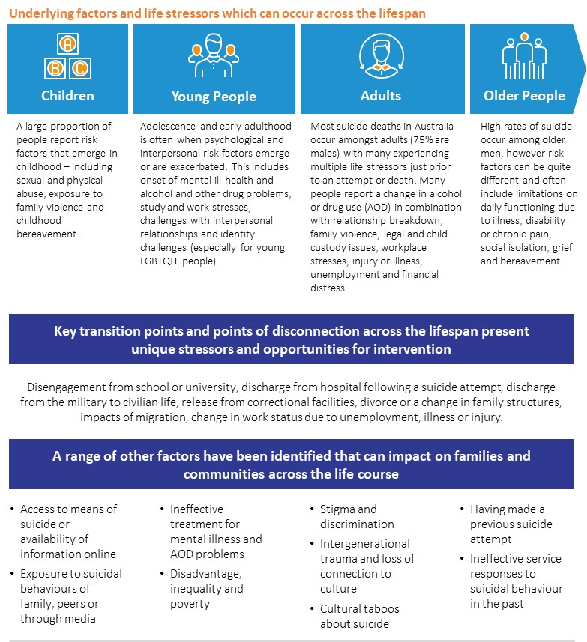
Co-occurring stressors and adverse life events
Most people reported that a number of life stressors and events co-occurred close in time before a suicide attempt. These included: interpersonal conflict; intimate partner and family violence; relationship breakdown and/or child custody issues; being bereaved by suicide; experiencing legal problems; and financial problems related to housing and employment. Some adverse life events were unique to particular groups. For example, in children and young people, suicidality was impacted by factors such as development of self-identity, bullying, neglect, issues with body image and study pressures. Adults were more likely to report relationship breakdown, child custody or child removal issues, contact with the justice and legal system, and unemployment or financial stress. Older people were more likely to talk about bereavement, social isolation and chronic pain or physical ill health.
Events or stressors that were adversarial in nature or involved conflict or disconnection were particularly prevalent in people’s journeys. This included relationship breakdown, which was the most common adverse event reported across the studies, as well as legal matters, contact with the police or justice system or issues surrounding workplace injury and workers compensation claims. Aboriginal and Torres Strait Islander people talked about the vulnerable state people were left in when having children removed. The use of alcohol or other drugs to ‘cope’ with trauma and stressors was common, as were other addictions such as gambling – often making the situation much worse for people.

“Abusive relationship for three years in the mid-2000s, took another three years to get out of. Next relationship also destructive. Work history patchy…workplaces have been chaotic (and) stressful, and short-term contracts have meant ongoing financial stress. This recent incident was preceded by high level of stress rather than suicidal ideation, and wanting pain to stop rather than wanting to die. “
Personal story, Private Voices study, UNE
Discrimination, stigma and inequality
Discrimination and stigma, whether towards a person’s culture, their identity or towards their suicidality could occur at both an individual and systemic level and were reported across the research. For example, people identifying as LGBTIQ+ experienced homophobic bullying, abuse, and violence, further exacerbated by stigma directed towards their suicidality itself.
Racism and discrimination was reported as isolating and disempowering by Aboriginal and Torres Strait Islander people within the yarning circle and through other national hearings. Racism and discrimination contribute to intergenerational trauma and can prevent equitable access to resources and services. This in turn can result in health inequalities, homelessness and overcrowding, educational and employment disadvantage, substance misuse, impulsive behaviour in relation to life stressors and overrepresentation in the justice system, especially for young people.
Discrimination in the context of cultural or social norms, along with the role of intersectionality, are important to contextualising the individual experience of suicidality. For example, LGBTIQ+ Aboriginal and Torres Strait Islander people can experience multiple layers of stigma and discrimination. The historical and contemporary experiences of this for Aboriginal and Torres Strait Islander people continue to affect their holistic wellbeing and intergenerational experiences. Aboriginal and Torres Strait Islander people and people from a CALD background highlighted that cultural norms and taboos could override familial relationships and reduce support for people who experienced suicidal thoughts.

“In my community mental health issues are problematic, there is a stigma, branding and spiritual abuse. Suicide attempts are frowned on and used to question religious observance of faith.”
Culturally and linguistically diverse interview participant
A loss of individual and societal value
The loss of a person’s sense of value, social role or status could contribute to suicidality, and this was particularly apparent in older populations, who often struggled with the loss of functioning and self-sufficiency. An increased reliance on others resulted in significant distress, due both to the feeling of losing autonomy and to perceptions that this made them a burden on others. For others, a loss of value or role was described in relation to job loss or financial stress and the subsequent loss of meaningful contribution. Some Aboriginal and Torres Strait Islander people spoke about the impact of needing to ‘prove’ identity or having identity denied.

“I come from generational dysfunction and a history of issues of comorbidity, I have had many years of therapy trying to break the cycle. I lack support due the stigma of mental illness, I don’t share my journey, the cycle is hard to break, I have been admitted to hospital due to suicide attempts after my son died by suicide…”
Personal story, Private Voices study, UNE
Loneliness and isolation
Loneliness and isolation were major precipitators to suicide and manifested in different ways across many different groups. Though the reasons for loneliness and isolation were not always provided, they could be caused by interpersonal conflict with peers and family members, disconnection from society, loss of support networks due to aging, experience of stigma and discrimination, poverty and isolating coping mechanisms. In other cases, isolation was caused by geographical isolation (rurality and limited service options), or through forced separation from support networks, such as in refugees and migrants and impacts associated with the removal of Aboriginal and Torres Strait islander children from families, from culture, language and country.

“I have lived with suicide ideation and many attempts. However, the most recent was back in 2013. Just prior to this attempt I was in severe financial stress. I was about to become homeless for the second time in a short period of time. I was isolated and estranged from family and friends.”
Personal story, Private Voices study, UNE
Feelings of hopelessness and emotional suffering at the time of crisis
A range of factors already mentioned, especially in combination, can culminate in hopelessness and extreme emotional distress. In some cases, suicidal behaviour was described as a method of coping with trauma and distress or an action they took because the self-harming behaviours they were using to manage distress no longer provided sufficient emotional relief. At the point of crisis, Aboriginal and Torres Strait Islander people talked about feeling unable to cope with “overwhelming emotions”, with some using substances as a way to cope. For people in detention, factors related to the detention environment itself, such as confinement, deprivation, loss of liberty, overcrowding, limited meaningful activities and exposure to others’ suicidal behaviour were noted as significant.

“I’ve had more services than most and I’m still not ok. So I feel trapped in a kind of hell where I can’t seem to find the way out of misery and I just wish I had cancer or something then it wouldn’t be my fault.”
Personal story, Private Voices study, UNE
Exposure to suicide and availability of methods
Research has identified that individuals can learn about suicide methods from television and film, news stories, the internet, and healthcare professionals. Within the research, it was common for participants to talk about their exposure to other people’s suicidal behaviours – both suicide attempts and deaths– within their family, within the school environment, among peers, in the workplace or through online communication. For Aboriginal and Torres Strait Islander people, ‘sorry business’, including other suicides in the extended family could increase feelings of being overwhelmed in the lead up to a suicide attempt.

“Lives are never the same after that, addictions, regret, anxiety, anger, waiting for the phone.”
Aboriginal and Torres Strait Islander Yarning Circle

Mapping journeys
While each person’s journey is unique, there were some common types of experiences identified through the research. By mapping the common experiences and themes identified in the previous section, we were able to highlight the interaction between experiences, their compounding effects, and how they can contribute to suicidal behaviour. Previous research has mapped the journeys of people who die by suicide. This report builds on that work by mapping the journeys of people who have survived a suicidal crisis and/or attempt. The common pathways identified have been mapped below to assist with identifying opportunities to interrupt a person’s path towards suicide earlier and ideally prevent suicide risk developing in the first place. They should not, however, be used in an attempt to simplify the complexity of experience of suicidal thoughts and behaviours for each person.

“It is extremely challenging to understand the complex phenomenon of suicide…the extensive knowledge base of risk and protective factors have relevance. But we ask that these are used with awareness of their limitations – they do not reflect every individual’s experience of suicidal thoughts and behaviours. Our complex internal experiences and interactions with an equally complex external world cannot be reduced to variables. We do not all follow the same theoretical pathway from suicidal thoughts to actions.”
Statement from Lived Experience contributor at the Black Dog Institute

Journey 1: Compounding experiences across the life course
This journey was described in more than half of the stories shared by adults across research and included: (1) adverse experiences in childhood; (2) psychological, relational and social challenges as a young person; and (3) co-occurring stressors in adulthood, often combined with a change in alcohol and other drug use immediately preceding the suicide attempt.
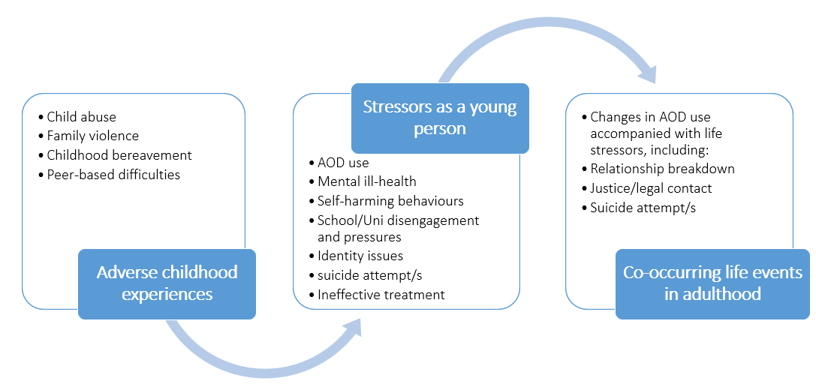
Journey 2: Co-occurring psychological, financial and relational stressors in adulthood
A number of adults described the co-occurrence of psychological, financial or workplace stressors in combination with relational stressors. While the timeline for these factors was not always clear, they were most commonly described as co-occurring within the space of one to five years. For people who described this journey, they did not consider any events occurring during their childhood or adolescence as significantly related to their journey towards suicidality.
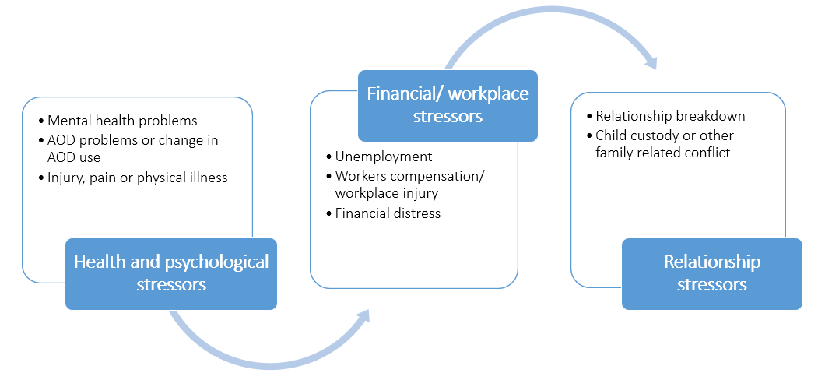

Journey 3: Complex mental illness and disadvantage contributing to suicidal behaviour of young people and adults
For some people, suicidal behaviour was described in the context of complex mental illness and comorbidity in adolescence or early adulthood, ineffective or disconnected treatment at the time followed by social disadvantage and justice contacts.
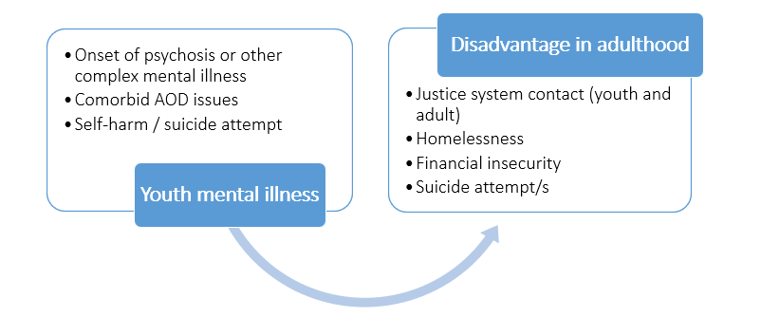
Journey 4: Experiences of young people
A specific consultation with young people, and experiences shared by young people in the online survey revealed that many had experienced adverse events in childhood (similar to journey 1) with the onset of mental ill-health and a range of stressors related to identity, relationships, academic achievement and financial stressors. There are opportunities to intervene early with young people and to ensure they receive effective and connected supports when they do actively ‘seek help’.
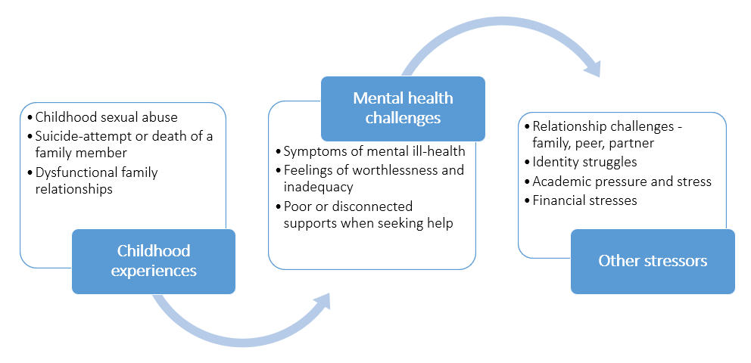
Journey 5: Experiences of Aboriginal and Torres Strait Islander people
Virtual yarning circles with Aboriginal and Torres Strait Islander people identified a number of ongoing and recent stressors prior to suicidal crisis. While there were some similarities with other journeys, with multiple stressors across the lifespan, disruptions to family life because of child removal, incarceration, trauma and ‘sorry business’ were common experiences, with increases in disconnection, alcohol and substance use and other risky behaviours close in time to a suicide attempt. Experiences of racism, inequity and limited safe options to seek help were mentioned.
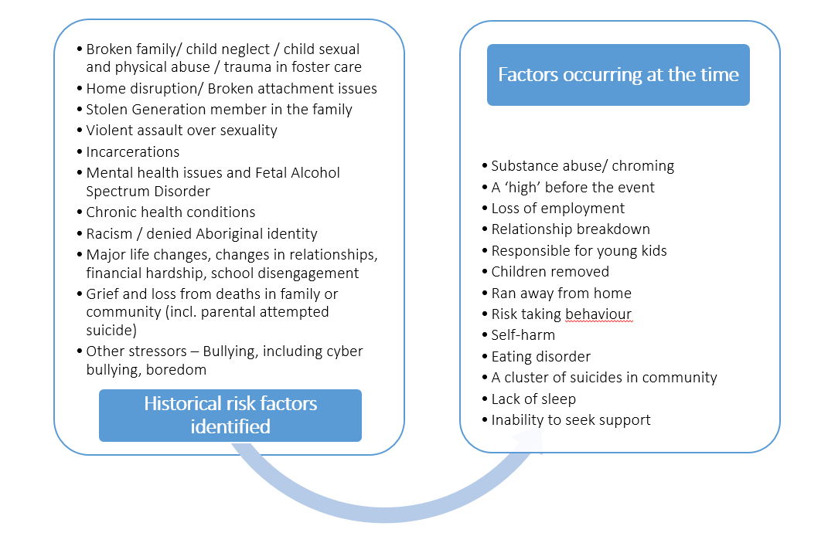
Journey 6: Experiences of Culturally and Linguistically Diverse people
It is difficult to determine whether there are particular journeys for people from CALD backgrounds given the diversity of cultures and experiences and the limited data available, but there were overlaying vulnerabilities identified in the research that may exacerbate journeys. Experiences are likely to differ by:
- Age of migration and family structure both overseas and in Australia.
- The type of migration (international education leading to permanent residency, skills and economic migration, refugee and humanitarian migration) and the impact of migration (including the reasons for migration, experiences during migration and supports provided).
- Service capacity and responsiveness to linguistic and cultural diversity, both during migration and for suicidality and supports (or lack of supports) from the broader community.
- Gender, with specific cultural expectation overlays for women and girls from CALD backgrounds in terms of their expected behaviour and cultural conformity.

Experiences with services

“I have attempted suicide several times when events in my life triggered PTSD which is the result of trauma in my childhood. I experienced some extremely negative responses by health professionals treating me, including a nurse who said I deserved to die and a doctor who said to me ‘look at how much you’re upsetting your mother’ (who was the problem to begin with). I experienced attitudes that I was attention seeking and a general lack of understanding.”
Personal story, Private Voices, UNE
Individuals described experiences of rejection, disempowerment, and invalidation when they interacted with the health system, often discouraging people from seeking help again.
People are often in contact with potential suicide prevention touchpoints before and throughout their suicide journey. If the touchpoints along people’s journeys are identified and resourced to provide support, there are numerous opportunities to assist people before they reach crisis point. However often people were required to ‘seek-help’ through disconnected health and community services that were crisis-driven and risk focused. People described feeling “unheard, judged and problematised”. The traumatic and systemic factors that often contribute to suicide were rarely acknowledged.

A crisis-driven system with multiple ‘drop-off’ points
The research described a common and distressing scenario where, precisely when people are highly distressed and in need of a compassionate response, our health system and other related systems provide disjointed care that is lacking in empathy or not available at all. The unintended consequence of this for most people is that responses appear to be doing more harm than good, perpetuating a vicious cycle where individuals in distress can only access support when in crisis at which point they are judged for not seeking help earlier. These experiences were traumatic and cultivated a distrust in the system and health professionals - often discouraging people to seek help again.
In a recent study of people presenting to the emergency department for suicidal crisis, only one-quarter reported being willing to return to the emergency department for a future crisis. Their satisfaction with the care they received while in the emergency department was the strongest predictor of their willingness to return and of their attendance at follow-up appointments. In an Australian data linkage study, only 41% of people who had been admitted to hospital following a suicide attempt had any contact with a public health service after discharge.

“I went to the hospital’s emergency department and they done an assessment and sent me home. They decided that I wasn’t at risk.”
“My experience at [a mental health service] was completely horrible. During the course of a year I had seen a total of five different psychologists and two different psychiatrists. There was a complete lack of consistency and it made treatment difficult. I felt patronised…”
Personal stories, Private Voices, UNE

For Aboriginal and Torres Strait Islander people, many considered asking for help to be “impossible”. They reported that non-Indigenous services were generally not trusted nor culturally safe and that Indigenous services were often avoided because of the “grapevine”. Many people reported a lack of trust in services due to poor experiences in the past as well as the sense of shame that can come from having to tell others about what has been happening in their lives. For some, this came with a real sense of fear that children could be taken into care if they were open about their thoughts and things that led up to the point of crisis.
A number of people spoke of challenging interactions with police who were often called on to do welfare checks or to transport someone to care and questioned whether they were adequately trained for their roles. Police are unfortunately a trigger for many Aboriginal and Torres Strait Islander people and their involvement can exacerbate or escalate the situation rather that get people to the support they urgently need.

“Shit does not happen on Monday to Friday, it happens at 3 o’clock in the morning.”
Aboriginal and Torres Strait Islander Yarning Circle

Being limited to ten sessions with a Mental Health Care Plan (MHCP) meant that people were often unable to continue treatment aside from receiving ‘episodic care’ and were often left without support whilst waiting for their sessions to restart. Young people and Aboriginal and Torres Strait Islander people reported significant financial costs to continuing to access regular professional assistance. Participants highlighted lack of coordinated care and case management services for people with mental health, trauma, chronic conditions, co-morbidities, or disability. This was particularly the case in regional and rural areas where there is a lack of both health and social services and long waiting lists for what is available. People also noted the limited options for seeking help – with too many services operating in business hours or with long wait times.
A number individuals across studies reported being rejected from services as their problems were seen as not being ‘serious’ enough. Exclusion criteria was used by services or clinicians, impacting on treatment and support, with access to services or continuation of services limited by complicated criteria to determine ‘who’ could get a service. For example, many young people reported experiencing a ‘merry-go-round’ journey, where they can be deemed too complex or severe for some services, but then cannot access others because they are deemed not severe enough.
Waitlists for both public and private services (for example, headspace, private psychologists, emergency department wait times, and inpatient admission) were identified as a barrier to care, with limited alternatives other than ‘one-off’ calls to a 24/7 crisis line if needed. Long waiting lists for the NDIS were an additional problem.

“There was no cushion, and there was no assistance, it was just a big old drop-off…there’s a lot of drop-off points, that could’ve made this ten year journey like four years.”
Personal story, youth consultation

Lack of communication, integration of services and follow-up
Poor integration and communication across services was described, leading to individuals having to tell their story multiple times to multiple health care providers, or decisions being made without consulting the other appropriate members of a person’s health care team. People also spoke of needing to try and navigate support options on their own which could be more isolating and distressing, especially when the referral systems were siloed – attempting to ‘treat’ just one presenting issue at a time rather than supporting a person as a whole. This meant that often people were not followed-up at all or had to restart their journey and retell their story.

“I was sanctioned under the Mental Health Act, but they couldn’t find a bed in a psych ward so was released with phone numbers and followed up once or twice, saw my GP a few times, found it really hard to navigate the system and couldn’t afford ongoing therapy. So still struggling and still fighting alone.”
Personal story, Private Voices study, UNE

The period following discharge or initial contact with health services was also identified as a critical time for support. Adults and young people admitted to hospital with suicidal ideation or who had a lifetime history of suicidal behaviour reported feeling anxious at the prospect of discharge and how their long term needs would be met. The distress caused by overlapping issues that were dealt with by a variety of organisations, often with no coordination was reported. This included the need for safe housing, responsive mental health support, addressing alcohol and other drug problems as well as support with education, work and finances.

“I had my most serious suicide attempt in September of last year. I ended up on a ventilator in ICU. I was also discharged home straight from ICU five days later after I told the psych team there is nothing more they could do for me…if I go into hospital I get a bunch of support only to come out to a follow up call from an acute care team who only ask a bunch of questions and move on to their next call…”
Personal story, Private Voices study, UNE
Variable responses about engagement with GPs was provided through the research. While some talked about their GPs going “above and beyond” to link them to care or following up until they were linked to additional supports, many others reported experiences of being “rushed through the appointment”, a lack of compassion or medication provided in the absence of any psychosocial care. For people from a CALD background, the GP was critical to accessing services, although they also experienced variable responses and had variable views about whether it was better or more challenging to see a GP from the same cultural background. In one case this was seen to be extremely beneficial and effective, while in other cases they suggested that medical practitioners from the same cultural and linguistic background could in fact reinforce existing cultural stigma and taboos around both mental health and suicidal crisis.

“Being told it was a two month wait to see a psychiatrist after feeling suicidal. Went back to GP who rang them back on my behalf and try and get me in earlier. Told nothing available. In the end my GP just had to star ringing around all psychiatrists in the city to find someone who could get me in within a week.”
“I reluctantly went to see a GP to tell them I needed a mental health treatment plan - it was horrible, I felt vulnerable and alone and rushed out of his office.”
Personal stories, Private Voices study, UNE
Interventions or therapies being ineffective or unhelpful was raised by many people, with young people experiencing poor therapeutic relationships at times, unhelpful techniques, or inappropriate treatments, which led to disengagement. Where treatment and counselling was effective, people reported benefits.
A focus on young people
Formal and informal supports were important in helping a young person recover from suicidality, however, these supports need to be better equipped to identity, manage, and respond to young people in ways that are validating and helpful. Young people’s help-seeking journeys were frequently difficult and complex, and contained many ‘drop-off’ points influenced by service access and care continuation issues. Young people experienced a variety of negative responses where supports were ill-equipped to deal with young people in crisis and responded in ways that were dismissive, invalidating, or judgmental. However, young people also experienced a variety of helpful responses, including supportive, validating, and accepting attitudes, genuine care and empathy, holistic and individualised approaches, and people going out of their way to assist.

Gaps in the system
Limited access for rural communities
Respondents described extremely limited access to health services in regional and rural towns. For example, there may be only one GP, and a GP is a gateway to other services by referral or via mental health care plans. Access to a psychiatrist was often limited to a brief appointment with a visiting psychiatrist once every six weeks. This was particularly problematic for people who did not respond well to the first anti-depressant they were prescribed and needed a medication review.

“Challenges of living as a young person in a remote/regional area: limited access to mental health support; job opportunities; costs of relocation and issues with living at home; drug use; loneliness; perceived misunderstanding; burdensomeness; lack of resources; parental capacity to support emotional and financial needs; (and) lack of sense of belonging.”
Personal story, Private Voices study, UNE
Lack of aged care services
Some respondents described lack of services for older people experiencing mental health, suicidality and aged care issues. Carer experiences of taking elderly parents to the GP and geriatrician did not result in access to care even when the older person stated they were suicidal. Hospitalisation following a suicide attempt also did not always result in the older person accessing assessment from a geriatric psychiatrist.
Inequity and socio-economic disadvantage
Drawing on survey data, a lack of affordable health services, financial distress experienced by many people, job loss and unemployment as well as class and educational differences between some service providers and service users (especially in rural areas), were all cited as barriers to accessing services and additional factors that contributed to suicidal behaviour. The data highlighted the need to consider equity and social justice issues in our service system and the need to address socioeconomic disadvantage, particularly in the current context of recession, wide-scale job losses and financial hardships experienced in rural communities affected by drought, bushfires and the pandemic.
Cultural competency and responsiveness
People from a CALD background reported that practitioners they accessed did not have a strong understanding of cultural contexts, nor the experience to operate in a cross-cultural service approach. There was also a belief that cultural community organisations and services would not be relevant or effective either in meeting the needs of CALD people experiencing a suicidal crisis, due to cultural beliefs, stigma and taboo. English language skills are critical to enable people to seek assistance beyond their cultural and linguistic community.

“At 14 my psychologist’s response was, ‘well, in two years you can move out and live on your own.’ This was his response to my ongoing issues with my mother and my deep depressions. He failed to understand that this is not the ‘done thing’ in my community. He made me feel incompetent.”
Culturally and Linguistically Diverse participant

Family, friends and identified caregivers are left unsupported
There was a clear lack of support for caregivers identified through the research. This was expressed across the continuum of care from caring for someone with suicide ideation, someone who had made suicide attempts and who had died by suicide. Many of these respondents have experienced their own suicidal ideation since their loved one’s death or attempt, with research suggesting that those who support and care for someone who has attempted or died by suicide being at greater risk of further suicidal behaviour themselves. Many caregivers reported being “ignored” by service providers while their loved one was in hospital or accessing services, but on discharge they were told they were now on “suicide watch” without any information or supports to understand this. There are also age and cultural variation to be considered in better supporting caregivers.

The need for a compassionate workforce
Many individuals described experiences of feeling disempowered, dehumanised and traumatised through contact with traditional services. This often started with emergency services personnel and the staff in the emergency department, but their experiences were carried through the system. This occurred through interactions with staff, who did not appear to take them seriously, were dismissive, stigmatising and judgmental, and excluded patients and their friends and family from treatment decisions. Aboriginal and Torres Strait Islander people and LGBTIQ+ communities also reported experiences of racism and an inability of medical professionals to recognise and respond appropriately to trauma. Many reported receiving only medication, which could lead to secondary problems, including addiction.

“The paramedics lectured me about it being a bad decision. It seems anyone involved wants to use guilt tripping as a way to prevent suicide…which doesn’t work. I needed validation not guilt trips.”
Personal story, Private Voices study, UNE
There were significant experiences of trauma, abuse and disadvantage through the stories of people who had attempted suicide or reached the point of suicidal crisis. However, people also reported that current approaches rarely acknowledged underlying trauma and that services were rarely trauma-informed in their approach, sometimes exacerbating distress. Multi-disciplinary services with specialised staff and peers are needed to support people with more complex and longer-term needs.

“We tend to get treated like, I would say criminals in a sense sometimes, if people are in crisis. For me, I have been probably quite traumatised…we may be unwell, and we may be not the best person to deal with, but you’ve got to be patient.”
Personal story, youth consultation
There was a sense through the research that a seismic rather than small shift in the approach is required. Survey respondents highlighted the need for more training for general practitioners, hospital staff and medical students so that it is not arbitrary whether someone receives adequate care when they go to hospital or contact a service. Other workforces were mentioned, including alcohol and other drug workers, psychologists, allied health professionals working with people impacted by workplace injuries and general health services supporting people living with chronic pain.

Experiences with other services and agencies
Many people who had experienced a suicidal crisis reported that they would be more likely to speak to a friend, family member or trusted community member before they would access a health service. Aboriginal and Torres Strait Islander people who had experienced a suicidal crisis, reported that they were more likely to speak to someone they trusted rather than to a service. These people could include school teachers or university lecturer as well as staff in specific programs targeted at young people who were disconnected from school.
A focus on community
Participants spoke about the general community needing to be more informed about the signs of suicide and how to respond to distress. In this sense, the general community was not described as a barrier per se, but rather as a potential touchpoint that could be more of an enabler if there was more awareness and community capacity. Those aware of community gatekeeper training passionately called for this to be more accessible, for more community members to be trained to support people, but also to assist in de-stigmatising suicide.
A range of government and community services could assist
A range of other potential supports and services were identified, including through housing and homelessness service, through legal centres and the family law court, through family and community services, including services that support people through domestic and family violence, as well as a range of financial and other community services. The following is a summary of some of the helpful and unhelpful places where support was sought or offered outside of health or mental health:
- Allied health: Psychology or counselling services for people bereaved by suicide or caring for someone following a suicide attempt. Marriage and relationship counselling services.
- Aged care services: Particularly in relation to bereavement, physical illness and isolation.
- Carer Support services: For caregivers of someone who is suicidal, living with disabilities or mental illness
- Crisis phone support and online support: Can be used in combination with other supports or may be the only support.
- Domestic violence services: Domestic violence counselling services and crisis support – focussed on victims as well as perpetrators and linking people to additional support.
- Emergency services: Police and paramedics are often called upon to support people in a crisis.
- Employers and employment services: This includes workplace support, Employee Assistance Programs, support following job loss, and workers compensation for workplace injuries
- Family and Community Services: Child protection services, family and community support services, family court and associated services who are often interacting families during vulnerable times.
- Financial services: Banks, credit unions and other financial institutions which can amend practices to support people in distress and connect people to supports.
- Healing services: Opportunities for healing practices to be integrated with a range of mainstream and Indigenous services and supports.
- Men’s Sheds and other peer-based supports for men: To access men who are traditionally not engaged with support services.
- Not for Profit organisations: Including NGO based 'after suicide programs' and counselling services provided in community.
- Personal care: Hairdressers, beauticians, other personal care providers.
- Schools and Universities: Counselling services, school psychologists, teachers, academics and peers, including coordinated responses to suicide attempts and suicide deaths to reduce distress.
- Youth services: Youth counselling services, drug and alcohol services, noting that headspace does not operate in all communities.

Helpful responses that shift trajectories
It is critical to understand what helpful and unhelpful responses ‘look like’ and ‘feel like’ from a personal perspective. It was clear from many of the responses provided for this research that not only background factors interact with life events to produce thoughts about suicide or distress, but that helpful and unhelpful responses could also play a role in someone’s journey. Suicidal behaviour can be cyclical, so there is a need for helpful interactions each and every time a person experiences distress.
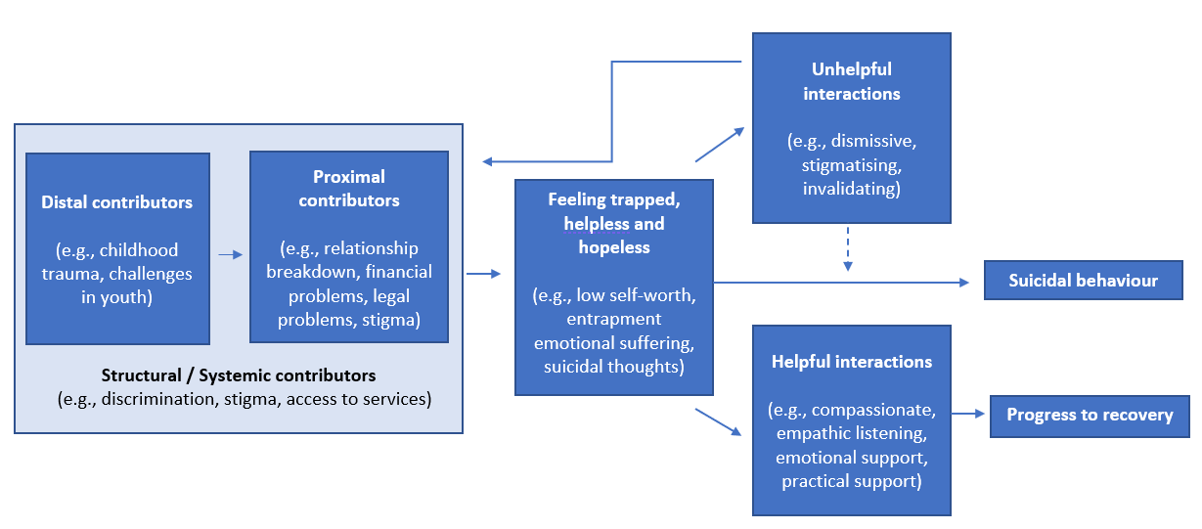
Throughout the research, participants described what they thought would be most helpful:
- Non-medical ‘safe spaces’: An overwhelming number of people spoke of the need for places and spaces where suicide could be freely discussed, where a fear-based response or crisis driven intervention is not immediately enacted. Rather where people can build relationships and trust in a ‘safe space’.
- Lived experience-led approaches: The inclusion of people with lived experiences in the education, programs and support for people increases trust and willingness to talk about suicidal thoughts and behaviours where they may not of have done so with others.
- Community driven approaches that can respond to diversity: Diversity in suicide prevention approaches is needed in order for them to be responsive to the local social and cultural context that underpin the needs of any community.
- Options for expanded community care and care-coordination: With general practitioners stretched across the country and with a preference for community rather than hospital based care, alternate models of care that consider other allied health professionals, peers and community agencies and care-coordination across multiple agencies was preferred.
- Long-term, ongoing treatment: The ability to access ongoing care rather than episodic care was identified as particularly useful as it gives people the ability to develop strong, positive relationships with service providers and address complicated problems. This can prevent the repeated need for crisis responses.

Shifting the lived experience narrative

“I believe the experts need to listen to people who have lived it and are still living with it. I have learnt to manage it but I can fall at any time so I have also learnt to know my triggers and seek help before it gets out of control. People with experience can provide essential insight into these situations.
Personal story, Private Voices study, UNE
There is a need to shift the lived experience voice from ‘anecdote’ to support professional views, to essential knowledge in design and delivery of suicide prevention.
There has been an increasing acknowledgement about the role of lived and living experience in suicide prevention, with a range of organisations now funded in Australia to support and upskill those with various lived experiences of suicide to share their knowledge. There have also been attempts to increase diversity of those voices. This research, however, highlights the need for acceleration of that work. The research conducted for this report points to the need for a serious shift in the public representation and narrative around suicide – including who it affects, how it is best responded to and transparency about the shortcomings of the current system. That shift must then be reflected in changes to the system, increased intervention at times of distress and a community wide understanding of the need for compassion and care.

Public voices: shifting from anecdote to expert
Analysis of the Public Voices research highlighted that while there was an increase in people with lived experience of suicide being included in public narratives about suicide (for example, through news media), they were often positioned as providing the ‘anecdote’ or ‘story’ that was followed up by an expert or medical point of view. An analysis of print media stories highlighted that stories about suicide and suicide prevention were dominated by the voices of medical professionals and service providers. They were often called on to share their interpretation of suicide on behalf of others, including the people with lived experience.
Statistics and reports were often used as a vehicle to discuss suicide, with limited inclusion of lived experience. Where lived experience was included, it was more likely to feature those bereaved by suicide (usually bereaved mothers), rather than those with direct experience of suicidality. This is despite the fact that research suggests that the stories of people who have lived through or overcome a suicidal crisis are the very type of media stories more likely to reduce stigma and reduce suicidal behavior, particularly when stories reflect a diverse range of backgrounds and experiences. Stories focused on suicide deaths, including stories presenting facts and figures and expert voices, have been associated with increases in suicidal behavior.
The lack of first-person accounts, with the focus on professional voices, has the potential to further isolate those living with suicidal thoughts. Indeed, analysis of social media accounts used by people with a lived experience of suicidality revealed that many felt frustrated, angry and distressed that the professional voice was ‘privileged’ and that the lived experience voice is not being heard. There were also some concerns shared that their experiences of suicidal crisis and what helped and what did not help was different from the views shared by those who have been bereaved by suicide, often preferred in media reports. When media formats such as podcasts were used to explore suicidality, the complexities of the issue were more likely to be identified and discussed. This included an exploration of workplace factors, mental ill-health, childhood abuse and adversity, men’s experiences, domestic violence, relationship breakdown, economic hardship and the experiences of particular population groups, including those who experienced migration challenges. These formats were also more likely to include those with direct experience of suicidality. This was in stark contrast to the brevity of stories and the lack of diversity noted through mainstream media stories.

Diversity in lived experience
While not fully explored through this research, there is a diversity of views and experiences among those with lived experience. This includes those bereaved by suicide, those caring for and supporting someone through suicidal distress, those who have attempted suicide and those who live with suicidal thoughts. Suicide prevention in Australia and globally owes much to people bereaved by suicide, who have often spear-headed community action, lead advocacy campaigns and called for service improvements. Their experiences are critical and should continue to be used to inform our suicide prevention and particularly our bereavement support and postvention activities.
There is also a need, however, to now elevate the voices of those who have directly experienced a suicidal crisis and those that have accessed, or have tried to access, services and supports through the current system. It is their voices that must be raised and heard if we are to rebuild trust, breakdown stigma and discrimination and design suicide prevention services and approaches that meet their needs. While each person’s journey and story is unique, their collective experience tells us much about what needs to shift. It will be critical to enhance the voice of young people, of Aboriginal and Torres Strait Islander people, of LGBTIQ+ people, of men and of other diverse groups with lived experience. It also requires a deeper understanding of the different types of lived experience and the benefits that each can bring.

Sharing as healing
Historically, suicide prevention research has been dominated by biomedical framings of the issues and research methodologies that exclude people with lived experience by positioning them paternalistically as people with impair decision making or too high-risk to participate. Studies which have examined the motivations of people with lived experience to participate in research, show that “sharing without censure” is the primary reason for participation. The opportunity to tell one’s story anonymously is a rare opportunity to speak and feel heard. The other primary reason was to help others through expanding the knowledge base about suicide prevention and wanting to change services so that others could have a better experience.
This was highlighted through the Aboriginal Lived Experience Yarning Circle where people felt their participation in the gathering was itself healing. They felt if gave voice to those who cannot be heard. Some felt that by talking about this subject, the young ones coming through would not feel weird about discussing it. In the written feedback given by participants, many said that they felt reaffirmed that they were not alone and that there were others sharing similar stories. The said that they felt culturally and spiritually safe and respected in the space, with some stating that they finished feeling empowered and uplifted.

“I personally feel privileged to have been in this circle, it was good to be able to talk about…suicide in a culturally, spiritually, safe and caring environment. I thought the debriefing session was really good and as we know the debriefing is one of the most important things for participating members and leaders in a session like this one.”
Aboriginal and Torres Strait Islander Yarning Circle

Opportunities for change

Personal accounts of almost 2,000 people and analysis of public narratives provides a range of opportunities to better understand the factors contributing to suicidal behaviour and what is needed to shift toward a comprehensive and compassion-first approach to suicide prevention.
Opportunity 1: Lived experience knowledge and expertise to be prioritised and integrated into the planning and delivery of whole of government suicide prevention action.
If systems and services are to truly meet the needs of people experiencing suicidal thoughts, suicidal distress and suicide attempts, they require active involvement of lived experience at all stages, from research that aims to build the evidence base, government policy and program planning, service design and delivery and evaluation. This capacity should continue to be developed within health as well as cross-portfolio agencies. It is also critical to have a diversity of lived experience represented – with services, programs and priorities designed with consideration to young people, men, Aboriginal and Torres Strait Islander people, LGBTIQ+ people (including Indigenous LGBTIQ+), people from CALD backgrounds and all other groups that experience suicidal distress.
- Lived experience should be central to designing outcome measures for suicide prevention services and programs, ensuring that outcomes are focussed on individuals and their caregivers.
- Further research focussed on lived experience journey mapping should be conducted, with a focus on better understanding opportunities to support groups more vulnerable to suicide.
- Enhanced national work to advocate a more balanced use of lived experience narratives and the positioning of those with lived experience as experts.
Opportunity 2: Population-level interventions that address key social and economic stressors implemented.
Many of the contributing factors to suicide identified through this research are beyond the remit of the health system and are aligned with the social determinants of health and wellbeing (e.g. social isolation, discrimination and economic stress). There is good evidence that non-health policies, especially when consistently implemented, can have an impact on suicidal behaviour. A whole-of-government approach to suicide prevention must be adopted through consideration of the policy settings likely to contribute to a reduction in population risk, continuously monitoring and evaluating initiatives, improving data collection and measurement to inform policy responses, and paying close and continual attention to emerging pressures that affect households, localities and communities. This approach is imperative to reducing suicidal risk, behaviour, attempts and deaths.
Opportunity 3: Intervene early in life to mitigate the impacts of abuse and adversity in childhood.
Adverse childhood experiences were highlighted as the start of a journey of poor mental health, unstable or violent relationships, social isolation and suicide attempts for many people. A greater focus on intervening early to mitigate the impacts abuse, adversity and trauma is required, with opportunities for targeted approaches. Given the circumstances surrounding the entry of children into the out-of-home care system, a targeted approach to children in care is also required.
Opportunity 4: Effective interventions and available support options for young people to mitigate the impacts of co-occurring psychological and relational stressors.
Up to 75% of mental health and drug and alcohol challenges emerge during adolescence, with young people highlighting the need for better coordinated and connected supports. Opportunities exist to design approaches with young people, considering the opportunities for prevention and early support through schools and universities, through youth services and health services. Continued coordination and access to youth mental health services and peer-led models of support are required.
Opportunity 5: A more comprehensive approach that addresses the multiple impacts of alcohol and other drug use on suicidal behaviour.
People with lived experience revealed that alcohol and other drugs had an impact across multiple points in their journeys. Many adverse experiences in childhood were described in the context of parental challenges with alcohol or substance misuse and many people reported their own alcohol and other drug issues commencing in adolescence (often before or in combination with the onset of mental illness). A recent change in alcohol use (particularly among men), was reported in the context of co-occurring life stressors such as relationship breakdown or job loss. There are opportunities for population level interventions to reduce access to alcohol and other drugs across the life course, to intervene early with young people to change attitudes to alcohol and to ensure effective and early treatment with opportunities to screen for alcohol use at key points of distress to provide pathways to brief or longer-term support.
Opportunity 6: Increased capacity to provide outreach and support at the point of distress to ensure people get the right supports in a timely way – especially at critical points of disconnection and transition
Stories of people who attempted suicide revealed that there were usually a range of co-occurring stressors that occurred close in time to an attempt. Particular attention needs to be paid where these stressors involve conflict or disconnection from supports in combination with increases in risky-behaviours such as alcohol and/or drug use. This may include outreach and targeted supports for people who are involved in family disputes, legal action, child custody arrangements and workplace disputes or workers compensation claims. Peer-support models and connection to face to face and digital services and screening may all be of benefit. This also includes earlier and proactive responses to distress that meet people ‘where they are’ rather than requiring them to seek-help in a crisis. It also includes targeted outreach and support at critical points of disconnection (from school, from work, from family), and transition (from justice settings, from certain workplaces such as the Australian Defence Force)

Opportunity 7: Increased supports for those exposed to the suicidal behaviour of others, in particular for Aboriginal and Torres Strait Islander communities and for young people in schools.
Exposure to the suicidal behaviour was reported frequently and needs to be considered as a point of distress for individuals and communities. While bereavement support and postvention approaches for schools and communities has been progressed to some degree in Australia, further attention is required. Bereavement and postvention support may also need to be tailored and targeted to particular ages (with a focus on children and young people), particular communities (with a continued focus on Aboriginal and Torres Strait Islander communities) and for particular workforces exposed to suicide (such as emergency services workers and people in industries or professions with high suicide rates). Non-health organisations (for example, schools, universities, workplaces), can also play a significant role in supporting bereavement activities.
Opportunity 8: A range of compassionate services and supports need to be available for people who do seek help in suicidal distress.
Many people identified ineffective care as a contributing factor to future suicide attempts, with a particular concern that services and supports were not trauma-informed or compassionate. The following were suggested throughout the research.
- Developing and supporting the broad range of workforces involved in suicide prevention to respond with compassion to underlying distress.
Developing and supporting the broad range of workforces involved in suicide prevention is needed to respond with compassion to underlying distress. Currently, health and other related professionals are required to complete separate training in overlapping areas (such as, suicidality, domestic violence, substance use), that require the same capacity for active listening, empathy, and compassionate care. Newer models of suicide prevention training emphasise the importance of a collaborative and therapeutic relationship. Training packages selected for delivery to health and other workforces should have compassionate responses as a stated foundation, be evidence based from the perspective of people accessing services, and have a focus on risk formulation and safety planning over risk identification and risk management. This should be supported by a review of policies, procedures and referral pathways across health and a range of other government and community services.
- New ‘entry’ points and service models that align with a compassionate response - including ‘safe spaces’ and peer-led services.
Accelerating new service models that use non-hospital peer-led approaches are needed. This also includes the ability to enter aftercare programs without needing to present to hospital. People in crisis often experience barriers to accessing care or sporadic, inconsistent care. Funding for a variety of services that complement and integrate with traditional services ensures that individuals have a constant source of support in a compassionate environment. This also requires training and development of a peer workforce to support these service models
- Improved health service responses – especially through emergency departments.
While new service models are progressed, there needs to be immediate action to improve health service responses through a review of emergency department procedures, workforce development for all health and emergency services workers and better supports for families and caregivers.
- Service models that support psychosocial needs, care-coordination and ongoing follow up – including broad access to aftercare.
People who experience a suicidal crisis often require a range of services, and yet this is a time when many people are often left to navigate several complex and difficult systems on their own – for example, disability support, income support, housing services and health services. Care coordination is generally carried out by aftercare services such as the Way Back Support Service, but this represents only a small proportion of people presenting in crisis (for example, it is often restricted to people who have already made a suicide attempt). Because of the siloed nature of care even within a single hospital, there is often little accountability for ensuring continuity of care within and across services. The role of care coordination is critical and should be resourced to better assist people.
- Safe and culturally appropriate services for all people
Equitable access to health and welfare services for Australia’s diverse population is key to preventing suicide. This includes upskilling workers to ensure that they are culturally competent, and diversity in hiring of staff. Where there are language barriers, translators should be made available. Providing detailed information online and in person about staff and available services (for example, languages spoken, training undertaken by staff), as well as clear statements of support for vulnerable populations (such as, LGBTIQ+, Aboriginal and/or Torres Strait Islanders), can help people feel safe and welcomed.
Opportunity 9. Better supports for family and caregivers, many of whom experience suicidal thinking themselves.
There is a clear lack of support for chosen caregivers as outlined through the research. This was expressed across the continuum of care from caring for someone with suicide ideation, someone who had made suicide attempts and someone who had died by suicide. Many of these respondents have experienced their own suicidal ideation since their loved one’s death or attempt. Family and other informal sources of support are the most frequently preferred first point of contact or disclosure of suicidality. For some, the role of being a support person is an ongoing one with its own limited support, and many people in a support role do not feel well equipped. While there are carer support groups in most jurisdictions, support people are unaware of these resources.
Opportunity 10. Interagency and cross-portfolio approaches that connect with and support people across a range of settings.
Suicide prevention cannot be the remit of health or mental health services alone. Co-ordinated interagency approaches would be more likely to respond to the range of social determinants contributing to suicidal behaviour and to better support people before they reach crisis point. This may be particularly critical in rural and regional areas, among Aboriginal and Torres Strait Islander people and among LGBTIQ+ people where there is a strong culture of distrust towards health professionals, or where past responses have further exacerbated distress. It would also better support engagement of men, many of whom may never reach out for help through a health service in the first place either because they do not view their experiences through a mental health lens or because mental health services are not designed in a way that meets their needs.

Acknowledgements and references

Acknowledgements
The National Suicide Prevention Taskforce would like to acknowledge Suicide Prevention Australia and all of the individual researchers who contributed to commissioned research informing this report:
- Professor Myfanwy Maple, Dr Sarah Wayland, Dr Sacha Kendall, Ms Phuong Hua, Ms Tania Pearce, Mr Jackson Newberry-Dupe, Dr Dorothy Ratnarajah and Dr Lesley Douglas (research lead by University of New England)
- Nicole Tujague, Kelleigh Ryan, Leilani Darwin, Tiarnee Schafer, Nathan Meteoro, Nicole Bloomfield, Catherine Carroll, Bonnie Love, Aunty Barbara Hubbert, Linda Medlin, Byanka Bilston, Roy Alick (research lead by the Aboriginal and Torres Strait Islander Lived Experience Centre)
- Dr Katherine Mok, Jo Riley, Hannah Rosebrock, Nyree Gale, Dr Ally Nicolopoulos, Dr Mark Larsen, Dr Susanne Armstrong, Cassandra Heffernan, George Laggis, Dr Michelle Torok and Dr Fiona Shand (research lead by Black Dog Institute)
- Associate Professor Jo Robinson, India Bellairs-Walsh, Pinar Thorn, Dr Louise La Sala, and Alexandra Boland (research lead by Orygen).
- Pino Migliorino AM and Lena Etuk (research lead by Cultural & Indigenous Research Centre Australia).
References

. Mok K, Riley J, Rosebrock H, Gale N, Nicolopoulos A, Larsen M, Armstrong S, Heffernan C, Laggis G, Torok M, Shand F. The lived experience of suicide: A rapid review. 2020; Black Dog Institute, Sydney.
. Maple M, Wayland S, Kendall S, Hua P, Pearce T, Newberry-Dupe J, Ratnarajah D, Douglas L. ‘They can only talk themselves out of it if they’re talking.’ A Report for the National Suicide Prevention Advisor and Suicide Prevention Taskforce. 2020; University of New England.
. Robinson J, Bellairs-Walsh I, Thorn P, La Sala L, Boland A. Young voices: A brief report on young people’s lived experiences of suicidality and help-seeking. 2020; Orygen.
. Tujague N, Ryan K, Darwin L, Schafer T, Meteoro N, Bloomfield N, Carroll C, Love, B, Hubbert B, Medlin L, Bilston B, Alick, R. We are Strong. We are Resilient. But we are Tired – Voices from the Aboriginal and Torres Strait Islander Lived Experience Centre Yarning Circles Report. 2020; Black Dog Institute, Sydney.
. Migliorino, P. National Suicide Prevention Taskforce: CALD Lived Experience Stage 1 Report. 2020; Cultural & Indigenous Research Centre Australia, Redfern.
. Ferlatte O, Oliffe JL, Salway T, Broom A, Bungay V, Rice S. Using photovoice to understand suicidality among gay, bisexual, and two-spirit men. Archives of Sexual Behavior; 2019; doi: 10.1007/s10508-019-1433-6.
. Williams SM, Frey LM, Stage DRL, Cerel J. Exploring lived experience in gender and sexual minority suicide attempt survivors. American Journal of Orthopsychiatry; 2018; doi: 10.1037/ort0000334.
. Education and Health Standing Committee. Learnings from the message stick - The report of the Inquiry into Aboriginal youth suicide in remote areas. Canberra: Commonwealth of Australia; 2016.
. Sales da Costa AL, Souza MLP. (2017). Narratives of family members on the suicide of older adults in an Amazonian metropolis. Revista de saude publica; 2017; doi 10.11606/s1518-8787.2017051007059.
. Commonwealth and Immigration Ombudsman. Suicide and self-harm in the immigration detention network. Canberra: Commonwealth of Australia; 2013.
. Biddle L, Cooper J, Owen-Smith A, Klineberg E, Bennewith O, Hawton K, Kapur N, Donovan J, Gunnell D. Qualitative interviewing with vulnerable populations: individuals’ experiences of participating in suicide and self-harm based research. Journal of Affective Disorders; 2013; doi: 10.1016/j.jad.2012.08.024.
. Clapperton A, Newstead S, Bugeja L, Pirkis J. Relative risk of suicide following exposure to recent stressors. Australian and New Zealand Journal of Public Health; 2019; doi: 10.1111/1753-6405.12886.
. Rosebrock H, Batterham P, Chen N, McGillivray L, Rheinberger D, Shand F, Torok M. Predicting willingness to return to the Emergency Department for a future crisis and follow-up appointment attendance following an initial suicide-related presentation: a cross-sectional study. 2020. Submitted for publication.
. Spittal M, Shand F, Christensen H, Brophy L, Pirkis J. Community mental health care after self-harm: A retrospective cohort study. Australian & New Zealand Journal of Psychiatry; 2016; doi: 10.1177/0004867416676366.
. Robinson J, Bellairs-Walsh I, Thorn P, La Sala L, & Boland A. Young voices: A brief report on young people’s lived experiences of suicidality and help-seeking. 2020; Orygen.
. Maple M, Cerel J, Sanford R, Pearce T, Jordan J. Is exposure to suicide beyond kin associated with risk for suicidal behavior? A systematic review of the evidence. Suicide and Life-Threatening Behavior; 2017; doi: 10.1111/sltb.12308.
. Adapted from Mok K, Riley J, Rosebrock H, Gale N, Nicolopoulos A, Larsen M, Armstrong S, Heffernan C, Laggis G, Torok M, Shand F. The lived experience of suicide: A rapid review. 2020; Black Dog Institute, Sydney.
. Maple M, Wayland S, Kendall S, Hua P, Pearce T, Newberry-Dupe J, Ratnarajah D, Douglas L. ‘They can only talk themselves out of it if they’re talking.’ A Report for the National Suicide Prevention Advisor and Suicide Prevention Taskforce. 2020; University of New England.
. Niederkrotenthaler T, Voracek M, Herberth A, Till B, Strauss M, Etzersdorfer E, Eisenwort B, Sonneck G. Role of media reports in completed and prevented suicide: Werther v. Papageno effects. The British Journal of Psychiatry; 2010; doi:10.1192/bjp.bp.109.074633.
. Gibson et al. 2014, cited in Maple, M., Wayland, S., Kendall, S., Hua, P., Pearce, T., Newberry-Dupe, J., Ratnarajah, D. & Douglas, L. ‘They can only talk themselves out of it if they’re talking.’ A Report for the National Suicide Prevention Advisor and Suicide Prevention Taskforce. 2020; University of New England.
. Maple M, Wayland S, Sanford R, Spillane A, Coker S. Carers motivations for, and experiences of, participating in suicide research. International Journal of Environmental Research and Public Health; 2020; doi: 10.3390/ijerph17051733.
. Maple M, Frey L, McKay K, Coker S, Grey S. ‘Nobody hears a silent cry for help’: Suicide attempt survivor’s experiences of disclosing during and after a crisis. Archives of Suicide Research; 2019; doi: 10.1080/13811118.2019.1658671.

