Shifting the Focus:   
A national whole-of-government approach to guide suicide prevention in Australia

A Report developed by the National Suicide Prevention Taskforce as part of the Interim Advice to the Prime Minister

August 2020

# Foreword

To create a genuinely effective, sustainable approach to suicide prevention, we need to […] look at how we live, how we communicate, and how we treat others, especially those who are vulnerable, and how our various systems—health, social, welfare, economic, education, and others—exacerbate or contribute to suicide   
**– Person with lived experience**

Suicide and suicidal behaviour will affect most Australians at some point in their lives, often leaving long lasting and far-reaching impacts on individuals, families, workplaces, services and communities.[1]

The impact of suicide cannot be measured only by loss of life. It also needs to be understood in the context of distress and resilience displayed by people who have lived experience of suicide attempts, suicidal distress and suicidal thoughts.

Often responses to suicidal behaviour are crisis driven and rely on the person in distress actively seeking help, usually through the health and hospital systems. However it is estimated that 30% to 50% of people who die by suicide do not seek help through these systems, or at all.[2],[3],[4] It is therefore not enough to wait for people to reach out, we must broaden supports and prevention activities to respond earlier, proactively reduce vulnerability, and enhance protective factors.

*Shifting the Focus* highlights the need for a collective call to action across multiple sectors and government portfolios. It has been developed for broad consultation and refinement with government portfolios, organisations and other relevant stakeholders.

**A national whole-of-government approach to suicide prevention is imperative**

It is through a shared understanding and commitment, with collective and aligned actions, that we can reduce suicidal behaviours and make a lasting impact for individuals and communities.

Traditionally the responsibility for suicide prevention has been given to health portfolios. While health services and the health system continue to have a critical and important role in suicide prevention, a broader and more connected response is needed through:

* Collective action across multiple portfolios and sectors
* A population-based approach which mitigates the social and economic circumstances that may increase vulnerabilities and which enhances protective factors
* Improving linkages across portfolios to enhance the total effort and impact
* Increasing transparency across multiple portfolios and sectors to ensure the actions of one arm of government do not contradict, or are counter-productive to, the efforts of others.

|  |  |  |  |
| --- | --- | --- | --- |
| **In Australia every year…** | | | |
|  |  |  |  |
| **Eight people** will die by suicide every day, six will be male[5] | **65,000** people attempt suicide[6] | Over **400,000** people are exposed to or impacted by suicidal behaviour | The economic impact of suicidal behaviour is approximately **$2.2billion**[7] |

# Shifting the focus



*Shifting the focus* seeks to drive a national whole-of-government approach to suicide prevention, through:

**A shared understanding of suicidal behaviour** which outlines the complexities and impacts of suicidal behaviour so there is a collective understanding across all governments, sectors and communities to inform actions.



**A comprehensive approach to suicide prevention** which outlines what all government portfolios and their agencies can do to make an impact through a whole-of-government approach to suicide prevention.



**Equipping the workforce** with the necessary skills and capabilities required to deliver compassionate and effective suicide prevention initiatives.

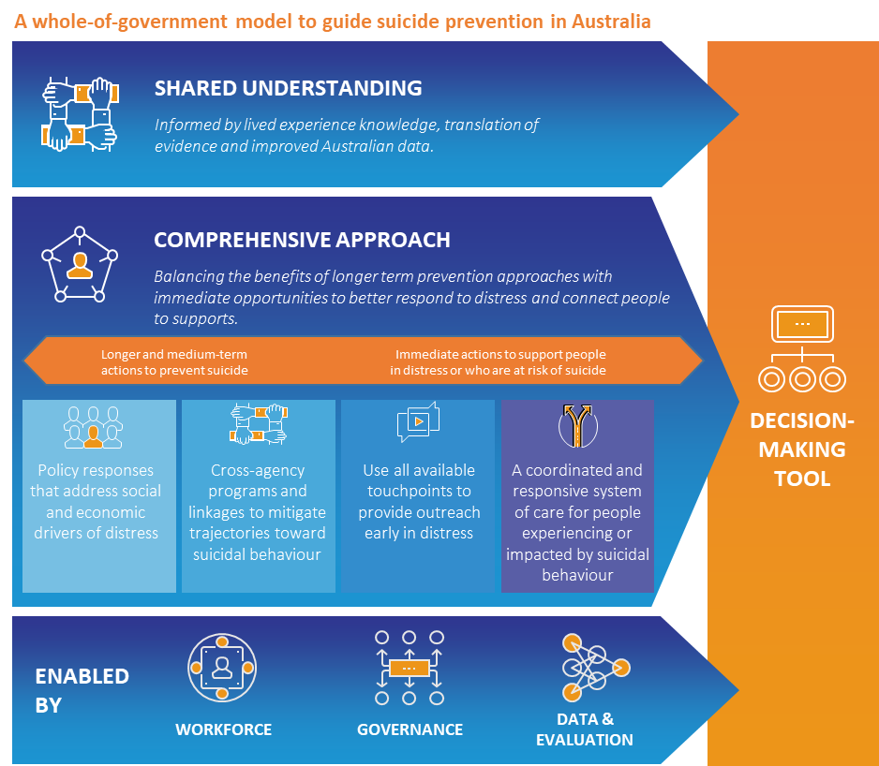

**Accountability through governance and data** whichprovides considerations for whole-of-government leadership and outlines how data and evaluation can be used to identify targeted suicide prevention initiatives and to monitor progress of a whole-of-government approach to suicide prevention.

**Decision making tool** which can be used by government portfolios and other agencies to practically guide their approach to suicide prevention.



# A shared understanding of suicidal behaviour

*I think the most important thing is communicating that suicide is a timeline, not an act. It's the whole play not just a scene.”* ***–* Person with lived experience**

## Suicidal behaviour is multi-factorial and deeply personal

Suicide is a complex behaviour underpinned by a range of factors and accompanied by intense distress and despair. Suicidal thoughts and behaviours can occur when people feel overwhelmed by their problems or their situation. This can happen to anyone at any time.

When people feel distressed, overwhelmed, trapped or defeated by their circumstances, they can find it hard to see a way through. People often report that they did not necessarily want to die, but they were unable to cope with the pain and despair any longer.

Suicidal behaviour is not an illness or disorder, although it can co-occur with, and be exacerbated by, a range of physical and mental illnesses. It occurs because of the interaction between biological, psychological, cultural and social factors, as well as what has happened in a person’s life.

Suicidal behaviour is generally not well understood. This can result in shame, stigma, discrimination and crisis-driven service responses.

Being suicidal is exhausting and all consuming. Most of the time, those who are suicidal are trying to keep […] life afloat. Expectations to reach out, follow up, navigate siloed services and systems, chase referrals, do extra or self-advocate are grossly unrealistic.”[8]

## There is no single pathway or set of factors that explain suicidal behaviour for all people

Recent Australian research, which captured thousands of first-person accounts of suicidal behaviour, highlighted that there is no simple lead up to a suicide attempt.8 People can experience a number of intersecting and compounding harms, vulnerabilities and events that can occur during their lifetime. These can operate at the societal, community, relationship or individual level and can change across the life course. Please refer to Appendix A for some key risk and protective factors identified through research.

People are often experiencing multiple stressors at the time that they attempt or die by suicide**.** They may become disconnected from their close relationships and social networks.Communities experiencing sudden, unexpected and/or unresolvable trauma or adversity, such as natural disasters, economic downturn, intergenerational disadvantage or clusters of suicide deaths, can also contribute to individuals’ vulnerability.

I have lived with suicide ideation and many attempts. The most recent […] I was in severe financial distress, about to become homeless for the second time in a short period. I was isolated and estranged from family and friends.”[9]

Underlying factors and life stressors need continual and long term attention across the lifespan, where efforts are aligned, multiple factors addressed simultaneously, and effort is targeted across a range of settings where people experiencing distress may be identified and supported.

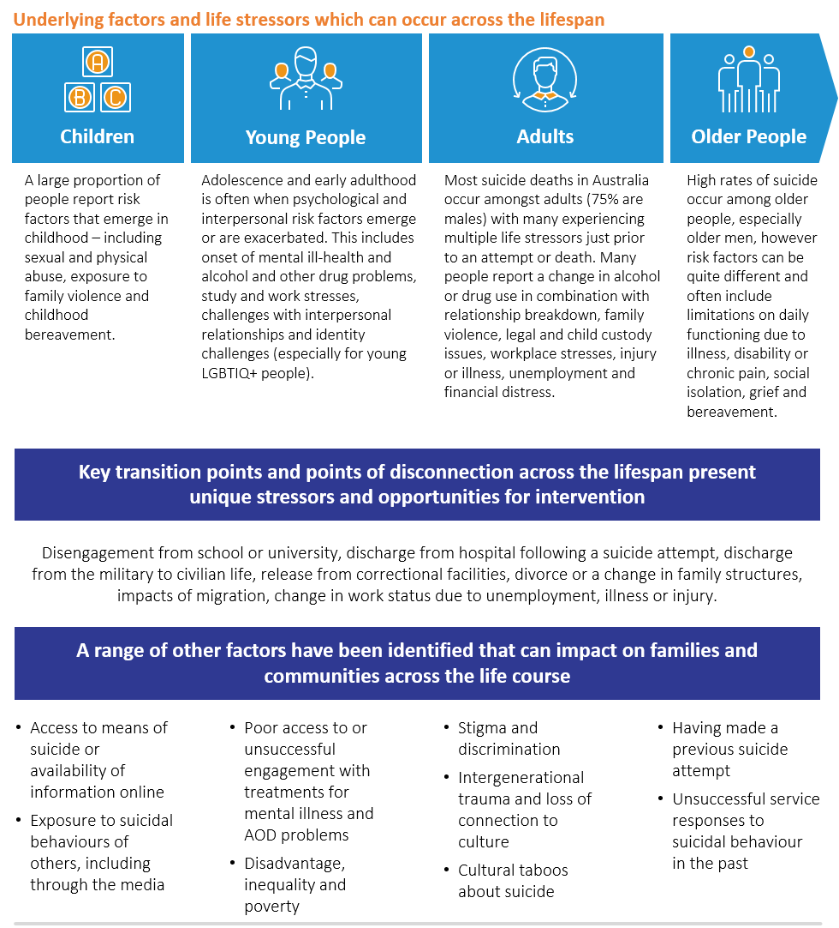

# There can be distinct factors which transition someone from *thinking* about suicide, to *acting* on those thoughts

A proactive, national whole-of-government approach leverages all available government and community touchpoints to mitigate the factors that contribute to distress and suicidal behaviour.

*“The extensive knowledge base of risk and protective factors have relevance. But we ask that these are used with awareness of their limitations—they do not reflect every individual’s experience of suicidal thoughts and behaviours. Our complex internal experiences and interactions with an equally complex external world cannot be reduced to variables.” 8*

Suicidal thinking can occur at any time that someone’s experiences and circumstances combine in a way that makes them feel shamed, disconnected, hopeless about the future, or a burden on others around them. It is not uncommon for people to have thoughts about suicide or more general thoughts about trying to end their pain. These thoughts can be frightening and often not easy for people to talk about. For some people, thoughts may come and go quickly, but for others they may persist for a long time.

In addition to these stressors, modern theories of suicidal behaviour[10] suggest that a different set of factors – or certain situations or experiences – have often been associated with people having the ‘capability’ to act on suicidal thoughts. These include:

* A prior suicide attempt or attempts
* A history of self-harming behaviour (even if not associated with suicidal thoughts at the time)
* Increased alcohol or substance use (in combination with life stressors)
* History of physical abuse or violence, including violence toward others
* Risk taking, antisocial or impulsive behaviours
* Occupational exposure to death, dying or physical pain
* Exposure to the suicidal behaviour of another person (through community or media)
* Access to lethal means and/or knowledge of suicide methods.

The factors that contribute to suicidal distress can vary between people and within an individual over time. While many people will experience thoughts about suicide before attempting or dying by suicide, others may not. Some people may transition quickly from acute distress in response to life stressors to suicidal behaviour.

## The experiences of some groups make them more vulnerable to suicidal behaviour than others

While suicidal behaviour can be experienced by everyone, some populations and groups can be disproportionately affected and targeted responses are required. These groups are not intrinsically more vulnerable to suicidal behaviour, but rather they may experience greater rates of discrimination, isolation and exclusion, or find it more difficult to ask for or access support. For example:

|  |  |
| --- | --- |
|  | 75% of people who die by suicide are **male**.[11] Men can experience a range of co-occurring life stressors, including relationship breakdown, unemployment and injury. They may change their use of alcohol and other drugs as a coping mechanism, or delay seeking help. Men may not readily access support through mental health services and sometimes these services are not well suited to meet men’s needs. The unique needs and experiences of men must be considered in providing support and responses, with a focus on local, immediate supports being provided ‘where men are’. |
|  | While young people have a lower rate of suicide compared to other age groups, suicide is a leading cause of death for **people aged 15-29**.[12] Adolescence and early adulthood is also the period where 75% of mental illnesses emerge, and when alcohol and other drug problems may arise; meaning early and effective treatments are imperative. Strategies to prevent suicide in young people need to reach and engage with young people. |
|  | **Aboriginal and Torres Strait Islander people** are twice as likely to die by suicide than non-Indigenous Australians, with young Aboriginal and Torres Strait Islander four times more likely to die by suicide.[13] Systemic factors such as discrimination, intergenerational trauma, disadvantage and cultural factors, such as experiences of shame, act as barriers to support being provided. Bereavement, including other suicides in the extended family or community, can increase feelings of being overwhelmed in the lead up to a suicide attempt. Culturally safe responses are needed which consider social, emotional and cultural wellbeing. |
|  | **LGBTIQ+** young people aged 16 to 27 are five times more likely to attempt suicide; with particularly high rates in transgender people[14]. LGBTIQ+ people often report feeling judged, stigmatised and discriminated against by broader society and may experience a lack of acceptance from people around them. They may also be unable to access supports and services due to fear of being misidentified or mistreated. Responses should be tailored to address the unique needs and safety of LGBTIQ+ people. |
|  | The suicide rate in **rural and regional areas** is 40% higher than in major cities. Rural and regional communities can experience sudden and ongoing adversity through extreme weather events which may result in widespread financial hardship.[15] Also, there can be fewer formal supports and professional services available compared with metropolitan areas. Strategies for rural and regional areas must consider available infrastructure, community supports and resourcing, including services having an understanding of the unique stressors that impact on rural and regional communities. |

A comprehensive approach to suicide prevention must focus on the whole population, as well as address the unique needs of specific groups through tailoring interventions and approaches that are most likely to proactively reach them.

# A comprehensive approach to suicide prevention

So often the services that people turn to in their most desperate moments are embedded in complex, bureaucratic systems where barriers to helpful responses – despite the best intentions and frustrations of people who work within them – are entrenched in culture, scarcity, power dynamics, risk management, and fear…   
**- Person with lived experience**

## No single government portfolio can undertake all actions required, but each can contribute – in appropriate and context-specific ways, separately and in partnership – as part of a comprehensive approach with shared responsibility.

The ‘solution’ lies, not only in what will help people stay alive, but also in what will enable all people, regardless of disadvantage or disability, to want to live.”8

*Suicide prevention must operate at all levels, and is best coordinated at the local level where people live, work, study and play. This means Commonwealth, State and Local Governments working together with community, non-government organisations (NGOs) and the private sector to coordinate prevention efforts at the regional level.*

Traditionally, the responsibility for suicide prevention has been given to health portfolios, with a range of suicide prevention plans, frameworks and policies currently in place (please see Appendix B).

Effective suicide prevention not only requires health intervention and support for individuals, but also for efforts to be aligned and responsibilities shared across multiple portfolios and sectors to respond to broader contributing factors.[16]

This section provides a consistent, yet simplified, approach that will help to guide and shape the different actions required across multiple portfolios. It may also be useful for other public and private organisations.

In particular, a whole-of-government approach must leverage existing linkages across portfolios to enhance collective actions, and to minimise the risk of some arms of government undertaking actions that contradict the efforts of another.

# It is only through a shared and comprehensive approach that the complexities of suicidal behaviour can be effectively addressed

*"Suicide prevention efforts require coordination and collaboration among […] both health and non-health sectors such as education, labour, agriculture, business, justice, law, defence, politics and the media. These efforts must be comprehensive, integrated and synergistic, as no single approach can impact alone on an issue as complex as suicide.” 17*

All government portfolios and agencies have opportunities to influence the wellbeing of Australians. A national whole-of-government suicide prevention approach must be delivered through, and link with, a range of departments, agencies, service systems and communities, as well as having defined priorities and accountabilities.

**Policy responses that address the social and economic drivers of distress** will serve as an effective long-term suicide prevention measure. This includes investment in reducing factors that contribute to vulnerability and distress, working to increase community safety and promoting protective factors at a population level.



**More cross-agency programs and linkages** through identifying and acting on opportunities to intervene early across various settings and programs; particularly where key transitions, points of disconnection or underlying vulnerabilities can be targeted to mitigate a trajectory towards suicide.



**Increased outreach in early distress** as it is not enough to wait for people to seek help in a crisis, as many never do. Identifying and using multiple government and community touchpoints where distress may present will enable a proactive and compassionate response to link a person to support. This can be provided directly, or through partnerships.



**Coordinated and responsive systems of care** which work together across portfolios and jurisdictions to provide holistic and comprehensive support to people across the lifespan, ensuring people receive the right support at the right intensity at the right time.

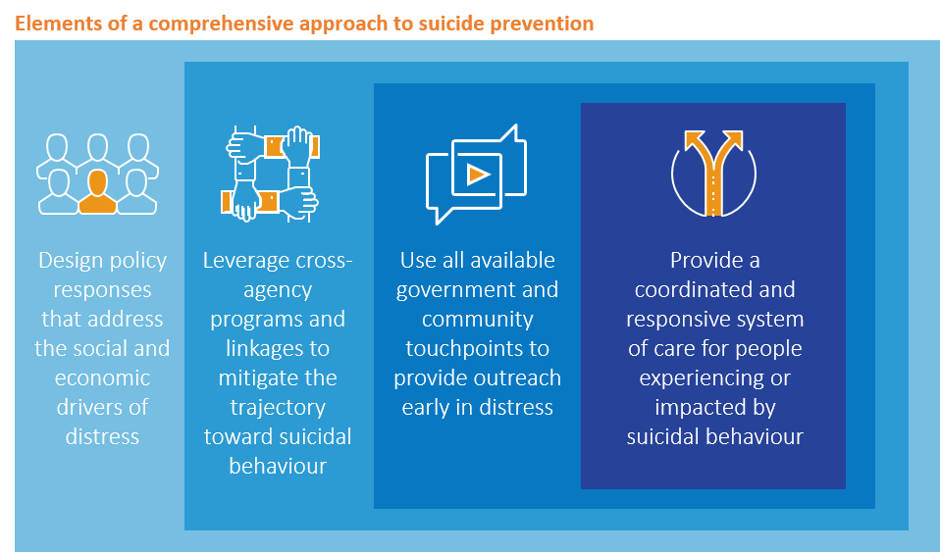

## Design policy responses that address the social and economic drivers of distress

|  |  |
| --- | --- |
| Effective policy responses can increase population wellbeing and safety, as well as decrease potential risks and increase protective factors at a population level. |  |

While each experience of suicide is individual, a broader public health approach is needed to have the greatest impact on preventing suicidal behaviour and underlying distress.16 ‘Upstream’ suicide prevention measures require governments to be aware of the broad range of factors and experiences that contribute to population-level distress, as well as factors known to exacerbate suicidal behaviour. Responses must be through policy and population-level initiatives which:

* **Are informed by data and evidence**, meaning continuous monitoring and evaluation of initiatives, improved data collection and measurement, and timely analysis to inform policy responses. Responses must pay close and continual attention to emerging pressures that affect individual, households, localities and communities.
* **Focus on promoting protective factors and increasing general wellbeing** particularly acrossthe long term – such as improving social cohesion, connection and psychosocial wellbeing, economic participation and security, and housing and welfare provision – to ensure the most vulnerable people have access to supports that improve their wellbeing.
* **Connection to family, place, culture and land is integral to healing for Aboriginal and Torres Strait Islander people,** therefore effective suicide prevention must include policies and investments that support social, emotional and cultural wellbeing.

I didn’t start healing until I went back to country. I went back to the brown water and then things started changing for me. We must remember how we heal.”[17]

* **Recognise and reduce factors that contribute to suicidal behaviour** through designing policies to support people and populations whose adverse life experiences and behaviours can make them vulnerable. This will reduce the number of people who experience vulnerability in the first place, and includes policies to reduce the overuse of alcohol and access to other drugs; financial and welfare support, especially during economic downturn; targeted support for people impacted by family, domestic and sexual violence; and ensuring policies provide targeted support immediately and in the longer-term for regions and populations most affected by particular adversity, including natural disasters and pandemics.
* **Ensure a suicide prevention lens is applied across all new policies and initiatives,** including considering suicide prevention outcomes as a routine undertaking by all government portfolios and agencies.
* **Reduce access to means** through regulation, physical barriers and reducing access to certain online and public information. This will improve safety and reduce lethality of behaviours, such as harmful use of alcohol and other drugs and self-harm.
* **Safe media reporting** that reduces the risk of further suicidal behaviour and decreases stigma. This can be achieved through regulation, guidelines and programs to increase safety online, ensuring availability of accurate information and increasing the use of lived experience stories. Portfolios must ensure all communication, public information and resources use best practice and safe language associated with suicide (please see Appendix B for further information).

Recent research exploring the experiences of people who have experienced suicidal distress revealed that many of the contributing factors (e.g. social isolation, discrimination, economic stress, exposure to abuse and violence) are beyond the remit of the health system. There is good evidence that non-health policies, especially when consistently implemented, can have the greatest impact on suicidal behaviour by shifting population risk and reducing the number of people who may find themselves needing to access services.9

|  |  |
| --- | --- |
| Key considerations | How do the services, programs or policies that you provide impact or influence people? |
| Does this impact or influence relate to any of the **settings or known risk factors** that can contribute to suicidal behaviour? |

## Leverage cross-agency programs and linkages to mitigate the trajectory toward suicidal behaviour

|  |  |
| --- | --- |
| Targeted interventions through collaborative and cross-portfolio responses to mitigate the trajectory towards suicidal behaviours. |  |

As people move through different stages in life, they will encounter a variety of transition points, times of disconnection and unique stressors, presenting multiple opportunities for their trajectory towards suicide to be addressed. Greater effort is required on responding early, both in a person’s life (i.e. during childhood) as well as early in a person’s journey (i.e. as early as possible when stressors or vulnerabilities are experienced). Government can utilise existing programs, as well as design programs in conjunction with other agencies, to enhance service provision and proactively support people and populations whose experiences leave them more vulnerable.

Programs must be tailored to the unique needs of specific groups,and pay particular attention to known transitional factors.

* **Focus on delivering evidence-based programs and services across a range of government, workplace and community settings** to reduce specific risk factors and ensure the greatest reach to people in distress. This includes justice settings, family relationship services, housing and homelessness services, social welfare services, schools and universities and children’s services, as well as focusing on reaching people who are isolated.
* **Apply targeted approaches to certain settings, industries and workplaces,** particularly where occupational risks may increase fearlessness about pain and death (e.g. male-dominated industries, emergency services, health professionals), exposure to trauma and death, workplace injury and people in prison or detention.
* **Tailor initiatives to target people and communities who are disproportionally impacted by suicidal risk and behaviour,** such as those who are socially isolated or who have multiple factors relating to adversity or disadvantage. This includes, but is not limited to, the LGBTIQ+ community, rural and remote communities and those experiencing mental illness.
* **Particular attention must be paid to targeting factors associated with the transition to suicidal behaviours,** regardless of whether people are presenting to a service. This includes being alert to self-harm, and risky or unusual behaviour including changes in a person’s use of alcohol and other drugs.

Services located everywhere and anywhere that might help deal with social, emotional, physical, financial, or spiritual problems or needs. From the grocery store to Centrelink, General Practitioner to Emergency Department, spiritual or religious supports to sports clubs.”8

[I] recklessly decided to seriously injure myself not caring about death, resulting in …financial expenses and hospital recovery instead. None of these times resulted in professional help, I only confided to my partner [about] one reckless attempt after the fact.”8

|  |  |
| --- | --- |
| Key considerations | How do your services, programs or policies work or intersect with those of other portfolios, agencies or service providers? |
| Do these need to work more closely and effectively with other portfolios and their agencies? How might you be able to do this? |

## Use all available government and community touchpoints to provide outreach early in distress

|  |  |
| --- | --- |
| Improved outcomes will be achieved through providing the right support, services and information for people to connect with early on. |  |

Every point of contact a person has with a government agency when they are experiencing distress, or which may contribute to distress, is an opportunity for suicide prevention.

As suicidal behaviour is a response to acute distress often involving multiple factors in a person’s life, the role of Government extends beyond health portfolios to all touchpoints where there is an opportunity to moderate distress. Government must incorporate the ability to act proactively in these instances and provide timely support.

* **Earlier and proactive supports are needed to improve responsiveness to early signs of distress.** The overwhelming majority of people only engage with services when there is an acute need or crisis, so to enhance suicide prevention responses must focus on identifying early signs of distress and meeting people ‘where they are’ to provide effective supports. This may include considering approaches such as outreach support to anyone presenting in distress until they can be linked to the right supports for their needs, and universal responses to self-harming behaviour.

|  |  |
| --- | --- |
| Key considerations | How might you need to refine and improve services, programs or policies to better and **more proactively respond** to suicide risk? |
| How can the insights of **people with lived experience** help you to do this? |

* **Identifying and providing earlier support during points of critical life stressors** – such as relationship breakdown, unemployment, workplace injury and financial distress. This can be facilitated by linking and sharing data across agencies to identify touchpoints with people in ongoing or situational distress, and ensuring service approaches and warm referrals to connect people with the supports they need when and where they need them.
* **Identifying and providing earlier support during life transitions regardless of suicidality**, including when people enter or exit government services or programs, such as discharge from the military, release from correctional facilities, entering an aged care facility, discharge from hospital following a suicidal crisis or suicide attempt, and disengagement with school. Engaging with the family court, for example, can also be an opportune transition phase to target support for fathers experiencing separation from their children and former family unit.
* **Providing outreach services across all service and community settings for people impacted by suicide attempts or deaths.** Cross-portfolio responses are needed to mitigate the impacts of suicide on communities, workplaces, schools and services.
* **Develop and expand partnerships.** Many people who become suicidal experience multiple factors of distress, meaning a multi-factorial response is needed. Clear linkages to other sectors and services must be identified to enable people to access the most effective supports in a timely and coordinated manner. Focus must be oriented to supporting service coordination, enabling the sharing of information across portfolios and jurisdictions, and removing barriers to care.
* **Broader understanding of the workforce involved in early outreach to ensure universal, compassionate and competent responses across settings**. The core competencies and training strategies for workforces that have a role to play in reaching people and providing support early on are discussed in following sections.

## Provide a coordinated and responsive system of care for people experiencing or impacted by suicidal behaviour

|  |  |
| --- | --- |
| Responses must be connected, coordinated and holistic to remove barriers for people to seek and receive help as they need it. |  |

As people seek help in varying ways and at any day or time, service responses need to be clearly communicated, accessible and appropriate for people wherever they live; with Governments ensuring that there is a connected and coordinated service system operating across multiple entry points within communities.

The health and mental health sectors and services will continue to play a vital role in suicide prevention. These responses, however, need to be complemented by the support and input of other portfolios and agencies. Services and supports for caregivers and people experiencing distress, bereavement or suicidal behaviour need to be fit-for-purpose, meet their needs, and be connected across the entire service system. This does not just require policy coordination and agency collaboration, but service linkage and coordination across sectors at the local level for a coordinated approach.

A coordinated and responsive system of care means that no matter when or where a person makes contact with supports or services, they receive a timely response that is compassionately delivered.

* **A full range of services and supports need to be available to meet diverse needs,** including services to support overall health and wellbeing, early intervention services and programs, crisis care and treatment services, and coordinated aftercare and postvention supports.
* **Service coordination at the local level**, so that the person receives consistent and effective care in their local community. This means that Primary Health Networks (PHNs), Local Health Districts and Areas, social services and other government agencies need to work together. In addition, funding and support must be provided for community-controlled services that are preferred providers for some populations (e.g. Aboriginal and Torres Strait Islander people or LGBTIQ+ people).
* **Ensuring a diverse range of services are delivered in ways that are appropriate and preferred by different population groups;** for example, e-counselling or a text-in service versus in-person counselling; or outreach to workplaces versus a reliance on individuals travelling to and accessing facility-based support. Linkages between these services should be accompanied by warm referrals at the point of distress, such as crisis line links to community-based supports that are relevant to the needs of the consumer.
* **Providing a range of clinical and non-clinical options across prevention, intervention, aftercare and postvention**, including peer-led, non-hospital and non-medical approaches as research highlights that these are the service models strongly preferred by people. For example, emergency department alternatives staffed by a mixture of clinical and peer-support workers with lived experience, with clear pathways to specialist supports as required.

|  |  |
| --- | --- |
| Key considerations | How do you currently work with other agencies to deliver services to people and communities? |
| How might your program or policy area need to **work in closer partnership with other agencies** to support a whole-of-government approach to suicide prevention? |

## What skills and competencies are required for the workforce?

# Equipping our workforces

* All government portfolios, and the services they fund, need to develop and support   
  their staff to enable a whole-of-government approach to suicide prevention
* While there are some universal competencies that are required for all people, the workforce is not homogenous and therefore skills required are different
* Training should be scaffolded and tailored to a person’s role and the type of   
  interactions they may have with people experiencing distress or vulnerability to suicide
* Training alone is not enough – workers need to be supported through healthy and safe workplaces, practical policies and support, and clear commitment from their leaders.

People experiencing distress interact with workforces across various sectors, at different times and in different ways. Every contact that a person has with a department, service or individual worker is an opportunity to have a positive impact, ensuring they get the right supports at the right time in line with the objectives of this model.

Outlined below is an overview of the main categories of government and public sector agencies, the required competencies for each and the training required to support this development (both formal and on-the-job).

Helpful responses are those that see our humanity, offer time and a safe space to be deeply listened to and validated, provide genuine compassion, free of judgement and agendas. This empowers a person to find their own meaning and the answers to the problems in their own life.”8

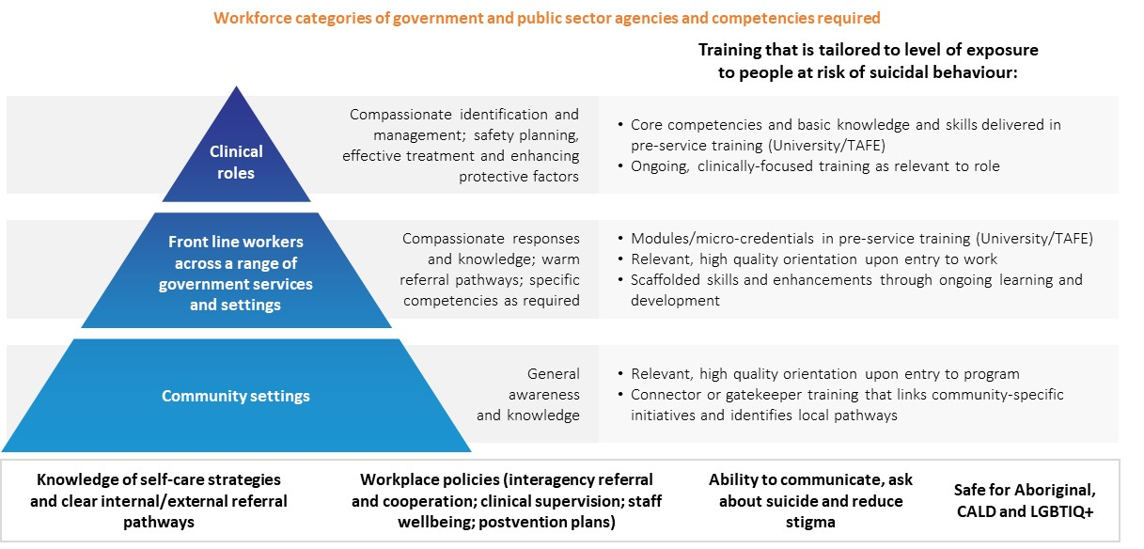

## How do we train and support these workforces?

Workforce development must be led by a commitment to the safety and support of workers who care for and respond to people in distress or who are experiencing suicidality, as workers who are supported are better able to support others. All government portfolios should work towards mentally healthy workplace approaches, with integration of suicide prevention, support and postvention policies and programs. Engagement of people with lived experience can have real benefits in increasing knowledge and breaking down stigma. Peer-to-peer approaches should be considered in addition to structural supports.

A culturally safe service environment and access to Indigenous or culturally competent staff for Indigenous people will be important”[18]

|  |
| --- |
| People will need particular skills  and competencies  related to their role – for example, those who work with men; those in rural and regional areas; people working with LGBTIQ+ people; and services connecting with Aboriginal and Torres Strait Islander people and communities. |

### Workforces can also actively contribute to reducing stigma around suicide and increase community capability through driving public campaigns. These outreach activities require distinct communication and organisation skills.

|  |  |
| --- | --- |
| Key considerations | How can you build the competence of your existing workforce to deliver and focus more on distress intervention at these points? |
| What strategies could you consider to attract and retain new skills in your workforces that relate to your suicide prevention initiatives? |

**Accountability through governance and data**

As suicide prevention is a priority across every sector at the Commonwealth, State and Local level, it is important to coordinate and cooperate with other levels of government and other government portfolios.

## Whole-of-government leadership and governance is central to the success of a shared and coordinated approach to suicide prevention.

Each portfolio or agency should consider the governance structure that will best support its suicide prevention initiatives and how they interact with other portfolios. Mechanisms that support this include:

**Leadership** which supports cross-portfolio approaches to suicide prevention and sustains suicide prevention from the top down.

**Shared and articulated commitment** **to suicide prevention** across all parts of the portfolio and which links to other sectors, between and across Commonwealth and jurisdictional government, and throughout public and private sectors.

**Clear roles, responsibilities and accountability** for an integrated approach across the portfolio and which links to Commonwealth, State and Local governments.

**Governance structures** to coordinate delivery of suicide prevention approaches within the portfolio that detail responsibilities for planning, implementing and evaluating initiatives, developing quality assurance frameworks and providing training in line with priorities.

Governance must also incorporate early input from the portfolio’s priority populations to ensure approaches are relevant, respectful and effective. This includes cultural governance inclusive of Indigenous people and integrating people with lived experience into planning and advisory stages.

## Ownership of collecting, using and sharing data is everybody’s business.

A national suicide prevention model requires timely, quality and relevant data to ensure the model remains current and evidence-based. This enables decision makers to act in a timely and informed manner, enables translatable research of suicide prevention activities and suicidal behaviours, and facilitates localised responses.

The ownership of collecting and using data relevant to suicide prevention must be a shared endeavour across government, community, public and private sectors; facilitated by a national system to collect and coordinate information on suicidal behaviour, risk factors and prevention activities.

## Data relating to factors surrounding suicidal behaviour should be collected and used for decisions on priorities and service improvements.

It is important to continually gain a better understanding of what factors contribute to suicidal behaviour and prevention in order to drive meaningful impact.

In particular, having **robust and reliable data insights about social, health, economic and cultural factors** that may impact on suicidal behaviour is needed. This is in addition to better collection and timely reporting of suicidal ideation, suicide attempts and suicide deaths to inform policy and practice.

Consequently, government agencies should ensure that internal data collection includes information relating to service contacts with people in distress, as well as where there are suicidal behaviours or incidents occurring. This data should align to demographic classifications and standard variables, including those relating to Aboriginal and Torres Strait Islander people, LGBTIQ+ people and culturally and linguistically diverse communities.

This helps to illuminate:

* Factors preceding or co-occurring with suicidal behaviour and/or change in suicidal intent
* Service contacts and types of supports accessed
* Effective early-intervention in distress efforts, reduction of suicidal crisis and attempts, and suicide prevention
* Service mapping and system modelling.

Government should leverage methodologies that identify the needs of consumers with lived experience and other priority populations, such as journey mapping, to inform the design and delivery of initiatives to improve the experience of interacting with all supports and services.

## Consistent and timely evaluation must be a priority for anyone implementing suicide prevention initiatives. It is vital to shift the focus and look at non-health related and longer term outcomes.

Everyone can contribute to the outputs described above by having **processes and governance to collect, link and share data.** This includes conducting routine analyses and reporting against tangible goals, targets and timeframes. Consideration must be given to where existing data relating to services can be leveraged or expanded to capture information at touchpoints with people at risk of, or experiencing, suicidality. It is also possible to look to a range of settings, including communities, families and social circles, and broader public discourse, to collect relevant information.

Importantly, translation of analyses and research findings must be routinely incorporated into policy and practice. Portfolios can facilitate this by **establishing a leader or decision-making body responsible for communication and priority-setting, and monitoring and improving the quality of relevant data.** Where possible, incorporate people with lived experience, researchers and experts in clinical and non-clinical care in this decision making for a holistic perspective.

## How do we measure success?

Collecting and having access to high-quality data informs the ability to identify targeted suicide prevention initiatives for portfolios. Consistent, timely, and appropriately resourced evaluation is also key to maximising the usefulness of data. That evaluation should measure success in reducing suicidal behaviours, reducing suicidal risk or increasing protective factors by the portfolio’s targeted initiative.

**Shared monitoring, reporting and evaluation frameworks**

Suicide prevention efforts will benefit from shared monitoring, reporting and evaluation frameworks that allow organisations to report on progress, and evaluate individual efforts against collective objectives in the short, medium and long term. Measures and targets should be at the individual, community, organisational and societal levels. They should be context and population specific, while directly reflecting the underlying causes, drivers, and protective factors for suicidality at multiple levels. Targets measuring structural change can include socio-economic factors, indicators of social norms, attitudes and relevant practices that drive suicidality at an individual level.

**Evaluation methods**

This includes quantitative and qualitative methods in process and outcomes evaluation. Process evaluations may examine how the initiative was implemented, assessing whether and how well services were delivered as intended. Impact evaluations examine the extent that an initiative’s activities have produced expected changes.

Monitoring and evaluation activities should bridge evidence-practice gaps, effectively assess impact and facilitate mutual learning.Some evaluation approaches, such as ‘action-research’, will enable implementation of learnings while establishing an evidence base, allowing for continuous improvement.

|  |  |
| --- | --- |
| Key considerations | What data are you using to identify your specific initiatives? Do they relate to an identified suicidal behaviour or risk that you are trying to reduce, or a protective factor you are trying to improve? |
| What will your tangible goals, targets and timeframes be for suicide prevention programs? How will you measure them? |
| Can you leverage existing data about your services and the key touchpoints with people at risk of suicidal behaviour? What improvements or additions to the data do you need? |

**A decision making tool**

This tool is intended for use by portfolios and agencies at all levels of government to assist them to develop an **Action Plan** for specific initiatives on suicide prevention. It will do this by:

* Helping agencies to identify key themes for attention in suicide prevention that are relevant to the functions and contacts that you operate
* Providing information that can be translated into key actions, priority functions and service enhancements that will contribute to suicide prevention.

The tool comprises a number of self-assessment and directional questions which serve as a review and planning exercise for portfolios and agencies to identify **how** and **what** you can do to better contribute to suicide prevention. The review process is in line with the national model, as follows:

|  |  |
| --- | --- |
|  | **Prepare**  Reviewing and identifying risk and protective factors and behaviours of concern based on a refreshed understanding of suicidal behaviour which relate to your sector. This includes using existing data to quantify interactions with people who are vulnerable to suicidal behaviour or distress. This will support you to identify the role/s that your portfolio or agency can play in suicide prevention and distress intervention. |
|  | **Assess and Identify**  Identifying how existing policies, services and programs interact with factors relating to people’s distress levels and trajectories towards suicidal behaviour. By using the four components of the national model, government portfolios and agencies can consider what enhancements or changes can be adopted to address those risks or behaviours. This includes recognising the resources, structures and systems needed to make change, namely workforce, governance and data accountability. |
|  | **Plan**  Developing clear Action Plans for suicide prevention, and to communicate and implement relevant initiatives. |
|  | **Monitor**  Continuous monitoring, evaluation and reporting of results to reduce concerning behaviours or risk, or in increasing or strengthening protective factors. |

The whole-of-government model should be read prior to using the decision making tool. Appendix A provides tangible and practical suggestions to assist portfolios and agencies to identify how you can contribute to suicide prevention.

Following completion of the decision making tool, government portfolios and agencies should develop clear Action Plans for suicide prevention initiatives which, once implemented, should be regularly monitored and evaluated.

Prepare

|  |  |
| --- | --- |
| **Understanding your role and influence in suicide prevention** | |
|  | How do the services, programs or policies that you provide impact or influence people? |
|  | Does this impact or influence relate to any of the known distress factors that can contribute to suicidal behaviour? |
|  | In what circumstances do your services, programs or policies engage with individuals that are vulnerable to suicidal behaviour? |
|  | What mechanisms do you have in place to identify behaviours of concern, risk factors and protective factors? |
|  | Do these mechanisms provide sufficient information to intervene? |
|  | What existing data can you leverage to quantify contact with people vulnerable to suicide? |
| Assess and Identify | |
| **Designing policy responses that address the social and economic drivers of distress** | |
|  | Are any of your services, policies or programs potentially counterproductive to effective suicide prevention? |
|  | How can you adapt or change your services, programs or policies to mitigate this impact or influence? |
|  | How could your portfolio / organisation include a dedicated focus on suicide prevention in: |
|  | * Policy? |
|  | * Priority directions? |
|  | * Commissioning of services and contracts? |
|  | * Performance measurement (i.e., to reduce behaviours or risks or increase protective factors)? |
|  | In what ways can your services, programs or policies better identify and provide targeted support for groups who are more vulnerable to suicidal behaviour? |
|  | How can you make existing services more accessible? |
| **Leverage cross-agency programs and linkages to mitigate the trajectory toward suicidal behaviour** | |
|  | Do you provide services or programs for people that have multiple needs that may interact with other agencies and services at the same time? |
|  | What data can you use to identify these people? |
|  | How do your services, programs or policies work or intersect with those of other portfolios, agencies or service providers? |
|  | Do these need to work more closely and effectively with other portfolios and their agencies? How might you be able to do this? |
|  | Do you have any existing partnerships that can be leveraged to provide a full range of services and supports? What opportunities are there to build new partnerships? |
| **Use all available government and community touchpoints to provide outreach early in distress** | |
|  | Do your services, programs or policies need to better target key stages across a person’s life? How could they be improved to provide earlier support? |
|  | How might you need to refine and improve services, programs or policies to deliver a more targeted approach to help people manage distress and/or navigate a transition period in their life? |
|  | What existing data and information can you leverage to identify people experiencing critical life stressors or transitions? How can you use this data to intervene earlier? |
| **Provide a coordinated and responsive system of care for people experiencing or impacted by suicidal behaviour** | |
|  | Do your services and programs link with other services? Can linkages be improved to enable better service coordination at the local level? |
|  | Do existing services or programs provide a range of different options to suit individual preferences? How can delivery methods be diversified to cater for different population groups? |
|  | How can you harness the knowledge and experience of people with lived experience of suicidal behaviour, attempts or death? |
| **Enablers of action** | |
| **Equipping your workforce** | |
|  | Which of your workforce/s interact with people experiencing distress and/or during points of vulnerability? Do they have the skills and capabilities to identify and provide support to people during these interactions? |
|  | How can you build the competence of your existing workforce to deliver and focus more on suicide prevention at these points? |
|  | Are there any staff that may interact with people during distress and points of vulnerability (e.g. Human Resources / People and Culture, parole officers, employment services staff) that may require additional training / capacity building? |
|  | What training can you provide to your staff? |
|  | What strategies could you consider to develop and retain new workforces to deliver your programs and other suicide prevention initiatives? |
| **Governance and data** | |
|  | How can your organisation better demonstrate a clear commitment to suicide prevention? |
|  | How can you better define governance and decision making structures to support suicide prevention policies, programs, activities and initiatives? |
|  | When working in partnership with other agencies or organisations to link into other suicide prevention programs, are there clearly defined roles, responsibilities and accountability? |
|  | How will you collect information and measure outcomes relating to your programs / activities / initiatives? |
|  | What will your tangible goals, targets and timeframes be? How will you measure them? |
|  | What improvements or additions to existing data do you need to make so you can monitor the effectiveness of your suicide prevention initiatives? |
|  | How can you increase data collection at key touchpoints? |
|  | How can you share this data and information with other agencies or sectors? |

|  |  |  |
| --- | --- | --- |
|  | **Plan**  Develop clear Action Plans for specific initiatives on suicide prevention relevant to your portfolio or agency. |  |
|  |  |  |
|  | **Monitor**  Continuously monitor and report outcomes to drive change that will have sustainable and longer term impacts. |  |

# Appendix A: Risk and protective factors

The following information is intended to be used as a tool by government portfolios and agencies to identify where a contribution can be made to suicide prevention. Key risk factors and protective factors are outlined across the four components of the model to provide practical and tangible suggestions for portfolios and agencies to better contribute to suicide prevention.

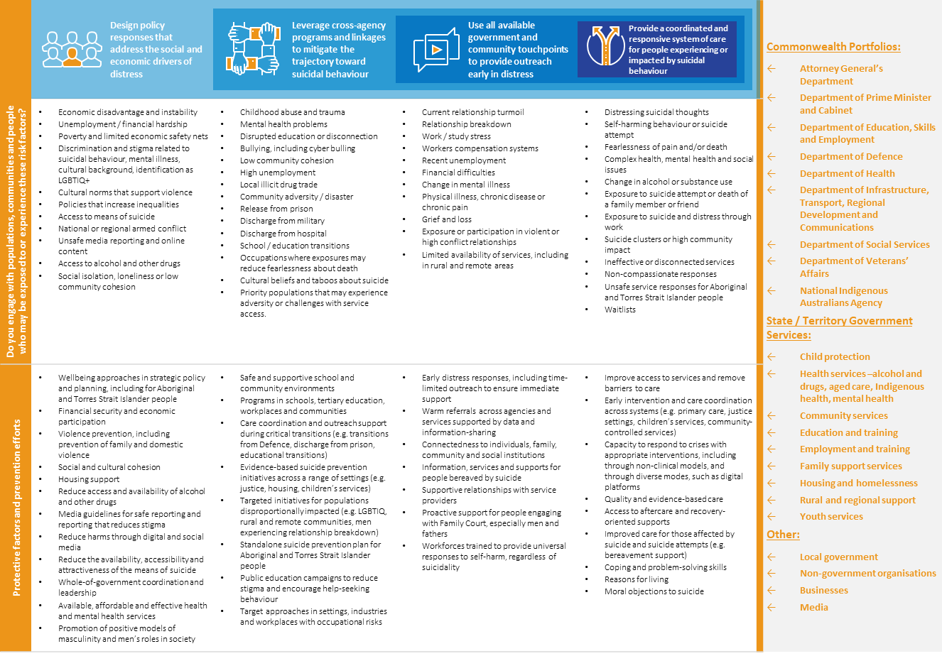

# Appendix B: Resources

There are a number of existing resources which can be leveraged by Government portfolios and agencies to drive new and existing suicide prevention activities.

|  |  |  |
| --- | --- | --- |
| **Training and other programs** | **Communication resources** | **Help-seeking information** |
| * Commonwealth portfolios will be rolling out workforce training, based on a compassion-led approach, to frontline workers to complement existing training and policies * Information on other available training for professionals and communities can be found at <https://lifeinmind.org.au/gatekeeper-training-search> | Government portfolios and other organisations should sign up to the National Communications Charter available at <https://lifeinmind.org.au/the-charter>  Those working with the media or preparing public content should refer to the Mindframe Guidelines - <https://mindframe.org.au/>   * Resources for young people communicating about suicide online are available via chatsafe - <https://www.orygen.org.au/chatsafe> | * Lifeline – 13 11 14, lifeline.org.au * Suicide Call Back Service – 1300 659 467, suicidecallbackservice.org.au * Beyond Blue – 1300 224 636, beyondblue.org.au/forums * Mensline Australia – 1300 789 978, mensline.org.au * Kids Helpline – 1800 551 800, kidshelpline.com.au * headspace – 1800 650 890, headspace.org.au * ReachOut – au.reachout.com * Head to Health mental health portal – headtohealth.gov.au * Life in Mind suicide prevention portal – lifeinmindaustralia.com.au * SANE online forums – saneforums.org * National Alcohol and Other Drugs Hotline – 1800 250 015 * LGBTIQ+ - 1800 184 527, qlife.org.au * Culturally and linguistically diverse resources – embracementalhealth.org.au, mhima.org.au * The Centre for Rural and Remote Mental Health – crrmh.com.au * Soldier On Veterans support – [soldieron.org.au](https://soldieron.org.au) * Department of Veteran’s Affairs – [www.dva.gov.au](http://www.dva.gov.au) |
| **Aboriginal and Torres Strait Islander people** |
| * Aboriginal and Torres Strait Islander support services and resource – healthinfonet.ecu.edu.au * Gayaa Dhuwi (Proud Spirit) Declaration can be accessed at <https://www.gayaadhuwi.org.au/resources/the-gayaa-dhuwi-proud-spirit-declaration/> |
| **National and State Suicide Prevention Policies** |
| * Life in Mind - [https://lifeinmind.org.au/national-policy](https://urldefense.com/v3/__https:/lifeinmind.org.au/national-policy__;!!E1R1dd1bLLODlQ4!T1plmV7dyAfgbyfVh7dKe5wLa3PipVuATQuwfv9AHSn7xr4hnmlIShrz5m3mh_QjiQ$) |

## References

1. . EveryMind. National Communications Charter: A unified approach to mental health and suicide prevention. 2018; Australia.
2. . Barnes LS, Ikeda RM, Kresnow MJ. Help-seeking behavior prior to nearly lethal suicide attempts. 2001; Suicide and Life-Threatening Behavior; 32(Supplement to Issue 1), 68-75.
3. . De Leo D, Draper BM, Snowdon J, Kõlves K. Contacts with health professionals before suicide: Missed opportunities for prevention? 2013; Comprehensive Psychiatry; 54(7), 1117-1123.
4. . Black Dog Institute. New digital-first service to be developed for people at risk of suicide. Sydney.
5. . Australian Bureau of Statistics. Causes of death. 2018; Canberra.
6. . Black Dog Institute. Facts about suicide in Australia. 2020; Sydney.
7. . Suicide Prevention Australia. Turning Points: Imagine a world without suicide. 2019; Sydney.
8. . Statement from Lived Experience Contributors, cited in Mok K, Riley J, Rosebrock H, Gale N, Nicolopoulos A, Larsen M, Armstrong S, Heffernan C, Laggis G, Torok M, Shand F. The lived experience of suicide: A rapid review. 2020; Black Dog Institute, Sydney.
9. . Personal story, cited in Maple M, Wayland S, Kendall S, Hua P, Pearce T, Newberry-Dupe J, Ratnarajah D, Douglas L. ‘They can only talk themselves out of it if they’re talking.’ A Report for the National Suicide Prevention Advisor and Suicide Prevention Taskforce. 2020; University of New England.
10. . O'Connor RC, Kirtley OJ. The integrated motivational–volitional model of suicidal behaviour. 2018; Philosophical Transactions of the Royal Society B: Biological Sciences, 373(1754), 20170268.
11. . Kolves K, Kumpula EK, De Leo D. Suicidal behaviours in men: determinants and prevention. 2013; Australian Institute for Suicide Research and Prevention, Brisbane.
12. . World Health Organization. Mental Health, Suicide data. 2019.
13. . Australian Bureau of Statistics. Population Projections. 2017; Canberra.
14. . National LGBTI health alliance. Snapshot of mental health and suicide prevention for LGBTI people. 2020.
15. . Berry HL, Hogan A, Owen J, Rickwood D, Fragar L. Climate change and farmers’ mental health: risks and responses. 2011; Asia-Pacific Journal of Public Health, 23(2), 119-132.
16. . Royal Commission into Victoria’s Mental Health System. Interim report. 2019.
17. . Personal story, cited in Tujague N, Ryan K, Darwin L, Schafer T, Meteoro N, Bloomfield N, Carroll C, Love B, Hubbert B, Medlin L, Bilston B, Alick R. We are Strong. We are Resilient. But we are Tired – Voices from the Aboriginal and Torres Strait Islander Lived Experience Centre Yarning Circles Report. 2020.
18. . Dudgeon P, Milroy J, Calma T, Luxford Y, Ring I, Walker R, Cox A, Georgatros G, Holland C. Aboriginal and Torres Strait Islander Suicide Prevention Evaluation Project Report. Solutions that work: what the evidence and our people tell us. 2016.